This week I might try:

To Stop Bullying

I’ll try to remember that there are 3 things I can try if I am bullying someone.

I can keep track of what I’m learning on the chart below:
I Can Stop Bullying: | Day  1 | Day  2 | Day  3 | Day  4 | Day  5
- Think back to when someone hurt me. How did it feel?

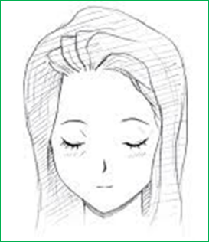

- Think about what I said or did to someone else. Was it helpful or hurtful? What can I do differently next time?

- Ask an adult for help
