What’s Happening Today?

Let’s Talk About Staying Safe on the School Bus

- There are different ways of getting to school. Some of us walk, some of us ride in cars, and some of us ride a school bus.

- No matter how we get to school, we have to stay safe. What are some of the ways we stay safe when we walk to school, drive to school, or take the bus to school?

- 5 School Bus Safety Rules

- Talk quietly
- Stay in your seat
- Don’t put anything out of the window
- Keep the aisle clear
- Wait for the bus to stop before getting up

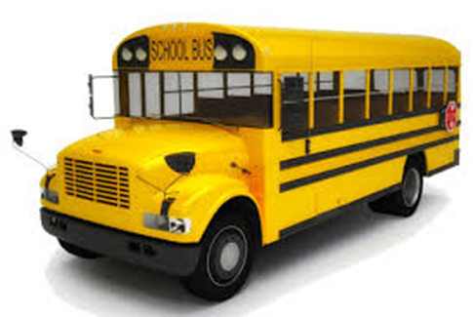
- Let’s look at some pictures – Who is being safe on the school bus? Who isn’t?

- So what do YOU think?

- Get your magnet

