This week I might try:

To stay safe on the school bus

I’ll try to remember that there are 5 rules to keep me safe on the school bus.

I can keep track of what I’m learning on the chart below:
My School Bus Safety Rules: | Day  1 | Day  2 | Day  3 | Day  4 | Day  5
- Talk quietly
- Stay in my seat

- Don’t put anything out of the window

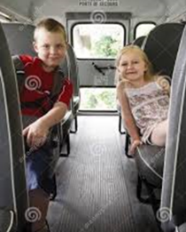
- Keep the aisle clear

- Wait for the bus to stop before getting up

