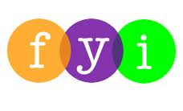
Social Skills – Teacher Note

Your student just completed a social skills lesson. The topic was:
I Can Show What I Know When I Gotta Go (to the Bathroom). Your knowledge of this lesson may help you to help your child generalize the skills to other environments.

What he/she learned:

- Using the school bathroom the right way can keep students safe, healthy – and out of trouble

- Students might need to do different things before they leave the classroom to use the bathroom (i.e. raise their hand to request permission, secret signal, bathroom pass, sign out, etc.)

- Students discussed the importance of having rules for the school bathroom – just like in the classroom. They viewed pictures of messy and clean bathrooms, and chose the bathroom they’d prefer to use, then explained why

- Students learned 4 School Bathroom Rules:

- Take care of myself
- Respect others
- Respect bathroom property
- Get back to class
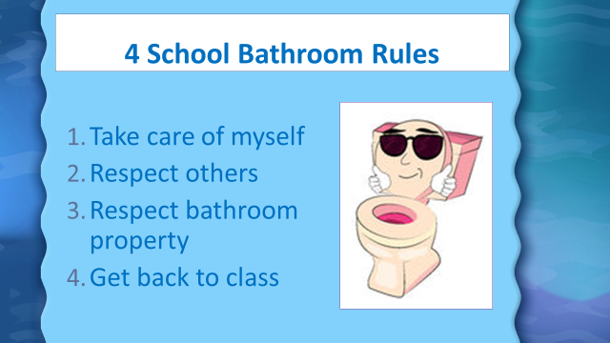
- So what do YOU think?

Your student received a Lesson Summary magnet:

If you have a moment, email _____________________________ with any information that might help your student for the next lesson on ________________________. THANK YOU!!

