This week I might try:

To handle put-downs with comebacks

I’ll try to remember that there are 4 ways to react to a put-down.

I can keep track of what I’m learning on the chart below:
If someone says a put-down to me, I can try to use the 4 types of comebacks | Day  1 | Day  2 | Day  3 | Day  4 | Day  5
- question it

- turn it into a compliment

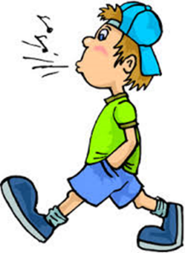
- ignore it - and walk away

- be amazed

