Social Skills –Parent Note

Your child just completed a social skills lesson. The topic was:
Saying “I’m Sorry” and Meaning It. Your knowledge of this lesson may help you to help your child generalize the skills to other environments.

What he/she learned:

- We all make mistakes. Sometimes our mistakes can hurt someone’s feelings or make someone mad. It’s what we do about the mistakes that’s important.

- There are different ways to apologize after we make a mistake. (face-to-face, on the phone, texting – but still asking to talk in person)

- It’s important to be sincere when apologizing. Our face and body language need to match what we’re saying for the other person to believe us.

- There are 4 parts to a good apology:

- apologize
- take responsibility
- say how you’ll fix it
- wait for a response

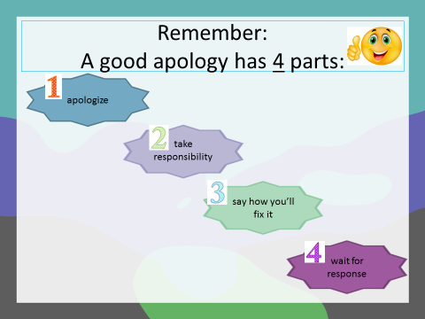
- So what do YOU think?

Your child received a Lesson Summary magnet:

If you have a moment, email _____________________________ with any information that might help your child for the next lesson on ________________________. THANK YOU!!

