DIRECTIONS: Mount on cardstock, cut apart and laminate the cards. Let each student pick a card and role-play the scenario. Remind students to use the 4 points of an apology when acting out their scenarios. Talk about different ways each situation could be handled.
ACTIVITY: Saying “I’m Sorry” Role-Play
You accidentally knocked your mom’s favorite coffee cup off the counter and it broke. What can you say to her? | You stayed up late to watch the end of your favorite movie and didn’t have time to finish your homework. What can you say to your teacher?
You poured the rest of the box of cereal into your bowl at breakfast and ate it. Your sister comes down to the kitchen and picks up the empty box, then looks at you. What can you say to her?  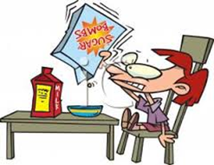 | You were joking around with your friends at lunch but something you said seemed to upset your best pal. What can you say to him?
You borrowed a classmate’s math book because you couldn’t find yours – but then you left it at home. The next day at school, she asks you for it but you don’t have it. What can you say to her?  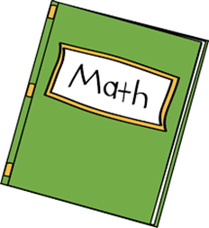 | You borrowed money from a friend to buy ice cream at lunch. A week later, he doesn’t have any money for a treat and you just used your last change to buy a bag of chips. What can you say to him?

