Social Skills – Teacher Note

Your student just completed a social skills lesson. The topic was:
I Can Handle Put-Downs. Your knowledge of this lesson may help you to help your student generalize the skills to other environments.

What he/she learned:

- What is a “put-down”? (An insult or criticism someone says to you) Put-downs can be about the way we look or something we do

- Put-downs can hurt our feelings or make us mad

- Reacting the right way can help make the put-downs stop

- 4 ways to handle put-downs with “comebacks”

- question it
- turn it into a compliment
- ignore it and walk away
- be amazed

- Stay calm and confident when delivering comebacks

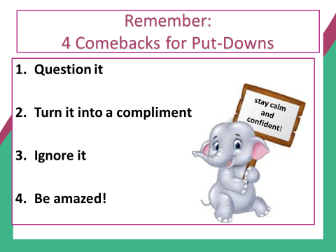
- So what do YOU think?

Your student received a Lesson Summary magnet:

If you have a moment, email _____________________________ with any information that might help your student for the next lesson on ________________________. THANK YOU!!

