What’s Happening Today?

Let’s Talk About How to Handle “Put-downs”

- What is a “put-down”?

- It can hurt our feelings or make us made. It can be about the way we look or something we do

- Reacting the right way can help make the put-downs stop

- 4 Ways to handle put-downs with “comebacks”

- Stay calm and confident

- So what do YOU think?
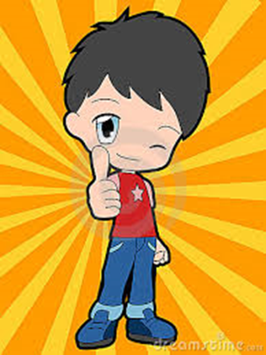
- Get your magnet!

