ACTIVITY: I CAN HANDLE PUT-DOWNS
SPINNER

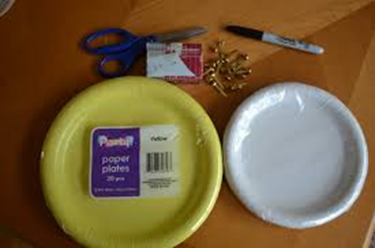
MATERIALS NEEDED:
- PAPER PLATES
- MARKERS
- BRASS PAPER FASTENERS
- SCISSORS
- COMEBACKS SHEET (below)
- GLUE STICKS
- PRE-CUT ARROWS (hole-punched at base)

- Give each student a paper plate and help them divide the plate into 4 equal parts with a marker
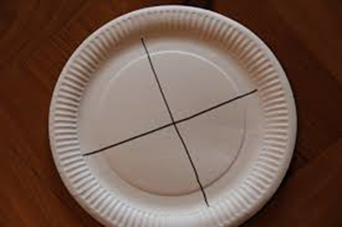
- Give each student a comeback sheet and ask them to
cut apart the 4 comebacks on the lines
- Tell the students to glue one of the comebacks in each
section of their plate
- Using the scissor point, help the students poke a hole in
center of their plates (*do this for the students when
safety is a concern)
- Help the students use the brass paper fasteners to
attach the arrows to the plates
- Make up silly put-downs (i.e. “Your nose is too curly”) and let each student take a turn spinning their arrow and practicing the comeback on the plate
- Keep it light and fun, but remind students about staying calm and confident when they deliver their comebacks

question it | turn it into a compliment
ignore it – and walk away | be amazed

