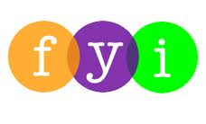
Social Skills – Teacher Note

Your student just completed a social skills lesson. The topic was:
Making Good Choices at School. Your knowledge of this lesson may help you to help your student generalize the skills to other environments.

What he/she learned:

- Making good choices means we need to be in control of our thoughts, words, and actions.

- Sometimes it’s hard to make a good choice if we’re mad, if we want something, or if we see someone else doing something and we join in.

- It’s easy to make good choices at school if we remember 3 things:

- Be Kind
- Be Safe
- Be Responsible

- Be Kind (helpful, not hurtful; nice words and actions)

- Be Safe (walk in hall, hands and feet to self, stay in own space)

- Be Responsible (“own” your mistakes; be accountable for your actions)

- So what do YOU think?
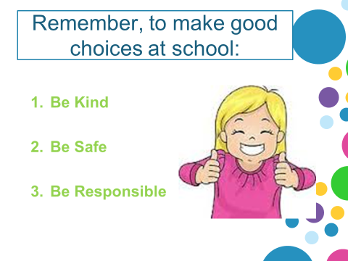

Your student received a Lesson Summary magnet:

If you have a moment, email _____________________________ with any information that might help your student for the next lesson on ________________________. THANK YOU!!

