ACTIVITY: MAKING GOOD CHOICES AT SCHOOL
CONSEQUENCE FLOW CHART

Make a copy of the Consequence Flow Chart below for each student. (Enlarge for ease of use.) Place each chart in a plastic page protector and give each student a dry-erase marker. Ask students to think about a situation where they may not have made a good choice and walk them through the consequences on their chart. Then talk about other choices they could have made that would have resulted in better outcomes. Help them write their responses in the boxes. Remind them of the 3 ways they learned to help make good choices at school (BE SAFE, BE KIND, BE RESPONSIBLE) when completing the chart.
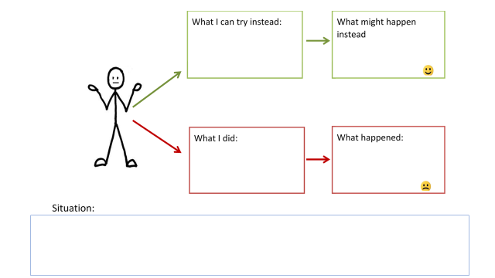
NOTE: Consider photocopying their completed charts before erasing to enable students to create a folder of better options to use the next time the same situation arises.

