Social Skills – Parent Note

Your child just completed a social skills lesson. The topic was:
I Can Tackle Test-Taking. Your knowledge of this lesson may help you to help your child generalize the skills to other environments.

What he/she learned:

- We have different feelings when taking tests (i.e. nervous, worried, anxious, etc.) These feelings can affect how we do on the tests, so we need to get them under control.

- We know we need to study before tests, but there are things we can do during tests that can help us.

- 5 Test-Taking Tips

- read the directions
- pace yourself
- read the whole question and all of the choices
- focus on the stuff you know
- check your work

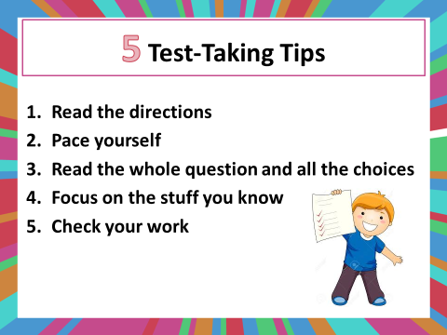
- Children were reminded that they might not ace every test, but they can try their best on every test

- So what do YOU think?

Your child received a Lesson Summary magnet:

If you have a moment, email _____________________________ with any information that might help your child for the next lesson on ________________________. THANK YOU!!

