This week I might try:

5 Test-Taking Tips

I’ll try to remember that there are 5 things I can do to help me when taking tests.

I can keep track of what I’m learning on the chart below:
I can try to: | Day  1 | Day  2 | Day  3 | Day  4 | Day  5
- Read the directions

- Pace myself

- Read the whole question and all the answers

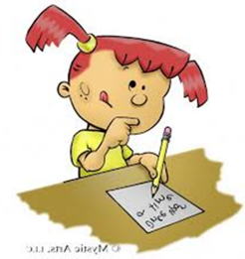
- Focus on the stuff I know

- Check your answers

