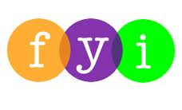
Social Skills – Parent Note

Your child just completed a social skills lesson. The topic was:
I Can Be Helpful – Not Bossy. Your knowledge of this lesson may help you to help your child generalize the skills to other environments.

What he/she learned:

- There’s a difference between being HELPFUL (politely reminding someone what the adult needs them to do) vs. being BOSSY (telling someone what YOU want them to do).

- Sometimes we might be bossy instead of helpful, so we need to watch 4 things:

- our tone of voice
- the words we say
- what our face is doing
- what our body is doing

- Children looked at different photos and identified those who were being helpful and those who were being bossy by using the 4 points above.

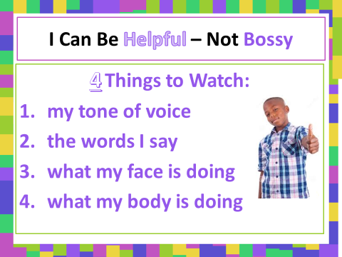
- So what do YOU think?

Your child received a Lesson Summary magnet:

If you have a moment, email _____________________________ with any information that might help your child for the next lesson on ________________________. THANK YOU!!

