This week I might try:

To be helpful – not bossy

I’ll try to remember that there are 4 things to watch to make sure I’m helpful, not bossy.

I can keep track of what I’m learning on the chart below:
I can try to be helpful – not bossy - if I remember to watch: | Day  1 | Day  2 | Day  3 | Day  4 | Day  5
- My tone of Voice

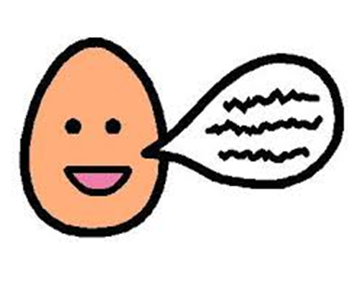
- The words I say

- What my face is doing

- What my body is doing

