FACT SHEET – GERMS AND YOUR HEALTH
There are germs around every day & everywhere. But there are many ways to keep healthy in spite of the germs – Here are some ways of those ways:
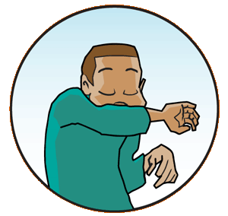
- If you have a cold or someone else has a cold – use tissues, turn your head if you sneeze or cough or sneeze and cough into your elbow.

- Wash your hands or use hand sanitizer – this is one of the best ways to ward off germs
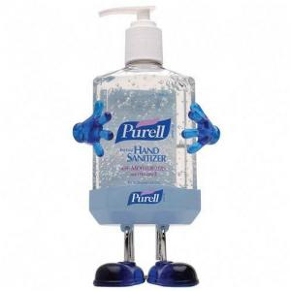
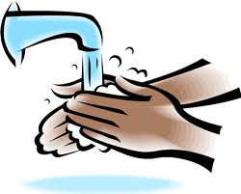

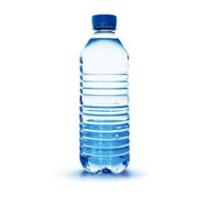
- Drink water – water keeps us all healthy

- Eat Healthy! Fruits and vegetables are great germ fighters

- Wipe down surfaces once a day to keep items clean
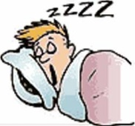
- Get plenty of sleep

Circle the things you have or do in your school and classroom to stay healthy.
And remember – It is good to have some germs and bacteria already in your body because then your body can fight germs better!!!!
Teachers at [insert name] School keep their students safe and healthy!
Insert school Picture

Yes it is true – we need some germs! The doctors say that some bacteria (a type of germ) are good for our bodies – they help keep things in balance.
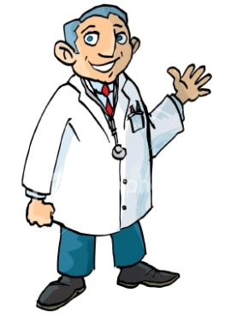
[name], did you know that you need some germs in your body to keep it healthy and working?

We have to help [name] – we are the good germs!
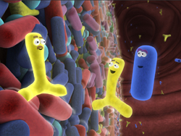
Good bacteria live in our intestines and help us use the nutrients in the food we eat and make waste from what's left over. We couldn't make the most of a healthy meal without these important helper germs!
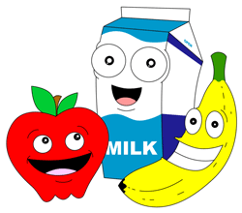
We need the healthy germs or we can’t make anyone healthy!

Some bacteria are also used by scientists in labs to produce medicines.
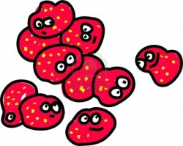
Now I can make medicine to help kids with my good germs
So remember: There are good germs and there are germs to help us. If we don’t have
any germs in our body we will NOT be healthy!!

The scientists want you to know there are good germs! They even write books about it!
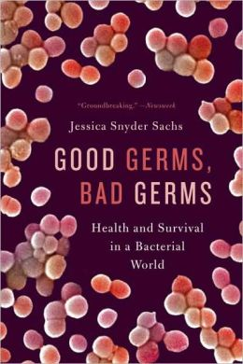

If you do the 6 healthy things to fight germs you will be fine. It is OK to ‘high 5’ people.
It is OK to touch things. You need some germs. Just do the 6 things a couple times a
day and all will be well. Try not to spit into your shirt. That can just get you wet and
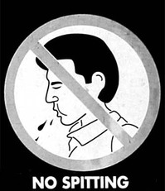
spread bad germs.

People don’t’ do that – they just do the 6 things.

