Taylor says – You Can Do It [student name]!
Lots of people have Self-Control. What is Self-Control?
Self control is when you:
Stop and Think 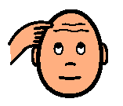
before you do or say something.
Sometimes when kids talk they ‘clap’ or say extra things like “Whew” or “Whoa”. That is OK…but sometimes it can bother other kids in the room.
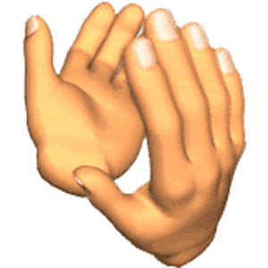

WHOA!

Oh my! That talking and clapping are bothering me! I can’t do my school work!

clapping
SO…what can a person do if she feels like clapping or feels like saying ‘whew’ or ‘whoa’?
They can try Self-Control. Look at these cartoon ‘helpers’
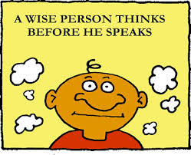
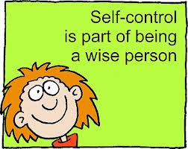
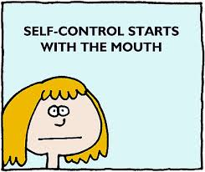
Self control is when you:
Stop and Think
before you do or say something.
If you feel like clapping, STOP and THINK,
Hey I can fold my hands or arms or I can open and close my hands like a hand exercise. That will be quiet and won’t bother anyone!
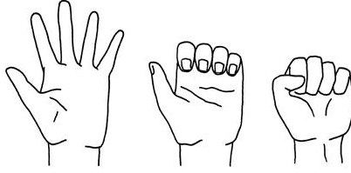
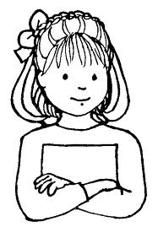
If a If a kid feels like talking and saying words a lot like ‘whew’, ‘whoa’, she can just whisper the words…then it won’t bother any one.

Guess who tries to do all these things…Taylor Swift! She knows everyone likes her singing but she also knows to be careful and not bother her friends with clapping or too much talking.
Uh oh, I have to remember to whisper and fold my hands so I don’t bother my friends. They like my singing but not all my talking!
She whispers so she doesn’t bother her friends.

Taylor folds her arms or hands if she feels like clapping because that might be too loud for her friends.

You can try this [student name]! Whisper or fold your arms or hands so it is quiet for your friends!

Try Self-Control ______! When you feel like clapping or talking too much remember to and
You can

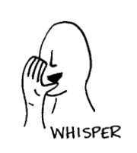
Thumbs up to ______ for trying!

