Sometimes I pick my nose. Next I sometimes put my finger in my mouth.
Yuck it is so GROSS to eat snots YUCK! DON’T DO IT!
People don’t like that.

It could make me sick too.
I feel sick – I should never put ‘snots’ in my mouth!! What was I thinking?!

When I want to pick my nose I need to use a tissue.
When I want to put snots or boogers in my mouth I need to STOP and put them in a tissue.
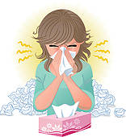
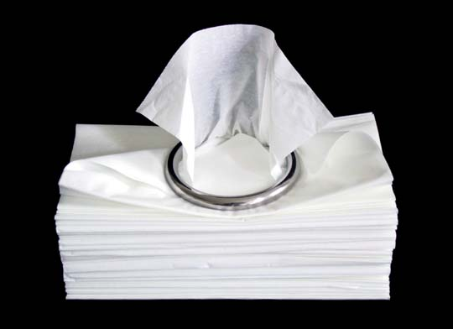
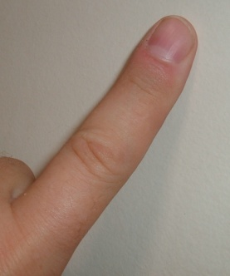

Everyone picks their nose sometimes BUT they are smart about HOW they do it. Here is the secret – there are actually choices –

- Stay where you are and just get a tissue, you can wrap it around your finger and put it in your nose. This will feel good, help get the boogers out AND it won’t spread germs to you or your friends!

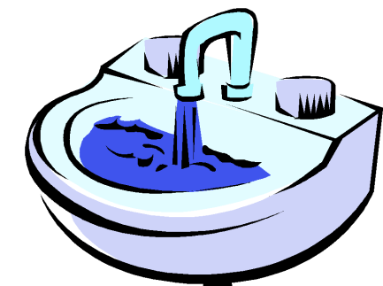
- Ask to go to the bathroom – it is a private place to pick your nose. But remember – WASH YOUR HANDS afterwards – to keep you healthy and everyone around you! Being sick is
no fun.

If an adult sees you using a tissue they might give you a starburst, an animal cracker, or a cat collector card, or a Barbie collector card! Try it and see!
Remember:
If your nose feels weird and you feel like ‘picking’:
- Try a tissue around your finger, or just blow your nose
- Ask to go to the restroom and do it privately then WASH YOUR HANDS!

Hey Suzzy, Great trying hard!

