Playing Games – What Geronimo Says

[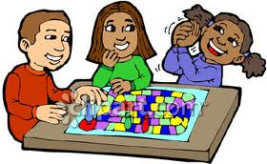](https://www.google.com/imgres?imgurl&imgrefurl=http://clipartpin.com/category/board-games-clipart&h=0&w=0&sz=1&tbnid=6XrumA2VaKdj0M&tbnh=172&tbnw=280&zoom=1&docid=qJ7fNtGSrboKgM&ei=mdedUsLjH4eDkQf7poEI&ved=0CAIQsCUoAA)

I like to play games. Sometimes kids win when they play games. Sometimes kids lose.

When I play games I like to win!

[](http://www.google.com/url?sa=i&rct=j&q=&esrc=s&frm=1&source=images&cd=&cad=rja&docid=sd6mMUcBZDI13M&tbnid=dgckghpkT5IGcM:&ved=0CAUQjRw&url=http://www.picturesof.net/search_term_pages/winning.html&ei=_NidUrjmE4qNkAfonYC4CA&psig=AFQjCNEMcjJ6VMr3QfxBmn87T5IJGWWL6A&ust=1386162761363173)

Sometimes I win. When I win I can say nice things.

Good Game!

That was fun!



Want to play again?

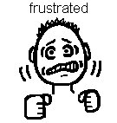

Sometimes I lose. I don’t like to lose. When I lose I feel very mad.

When I lose, sometimes I cry, whine, yell, and say mean things

[](https://www.google.com/imgres?imgurl&imgrefurl=http://www.clipartof.com/interior_wall_decor/details/Mad-Boy-Angrily-Pointing-Poster-Art-Print-1087419&h=0&w=0&sz=1&tbnid=3CNqn9CyNz5QMM&tbnh=279&tbnw=180&zoom=1&docid=bG3t4o39AzYORM&ei=Xt6dUpW4IorIkAec6YDwDA&ved=0CAgQsCUoAw)

Cory Thoman

You cheat! I don’t like you!

When I get mad and yell, this makes the winner sad. Kids will think that I am a poor sport and mean.

Why did [name] yell at me?

He’s not nice!



I don’t like him!

Kids will not want to play games with me. That will make me sad because I like to play games.

I’m sad.

I don’t want to play with you!



When I lose, I need to STOP, take a deep breath, and think…. “What would Geronimo do?” He would say, “Maybe I’ll win next time.”

[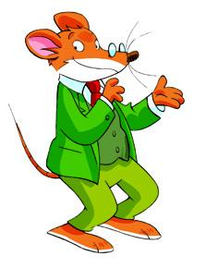](http://www.google.com/url?sa=i&rct=j&q=&esrc=s&frm=1&source=images&cd=&cad=rja&docid=7fbiMQ7pIo4ioM&tbnid=mXuDjdr0vfh8-M:&ved=0CAUQjRw&url=http://bookboxdaily.scholastic.com/2011/03/23/geronimo-and-thea-stilton-writing-contest/&ei=yeqdUvb8IozMkAf0uYGoDw&bvm=bv.57155469,d.cWc&psig=AFQjCNFfXjTkX7K3JqUCzQfTTSjb93Zc4A&ust=1386166792306812)

Maybe I’ll win next time!



When I lose I will try and say, “Maybe I’ll win next time. I can tell my friends, “Good game!” “That was fun!” “Let’s play again.”

Good game!



Maybe next time I’ll win.

Let’s play again.

Geronimo has another idea too. He says if losing is too hard you can say: “I just want to keep score.” OR “I’ll be the caller.” That can be fun and easy too!

[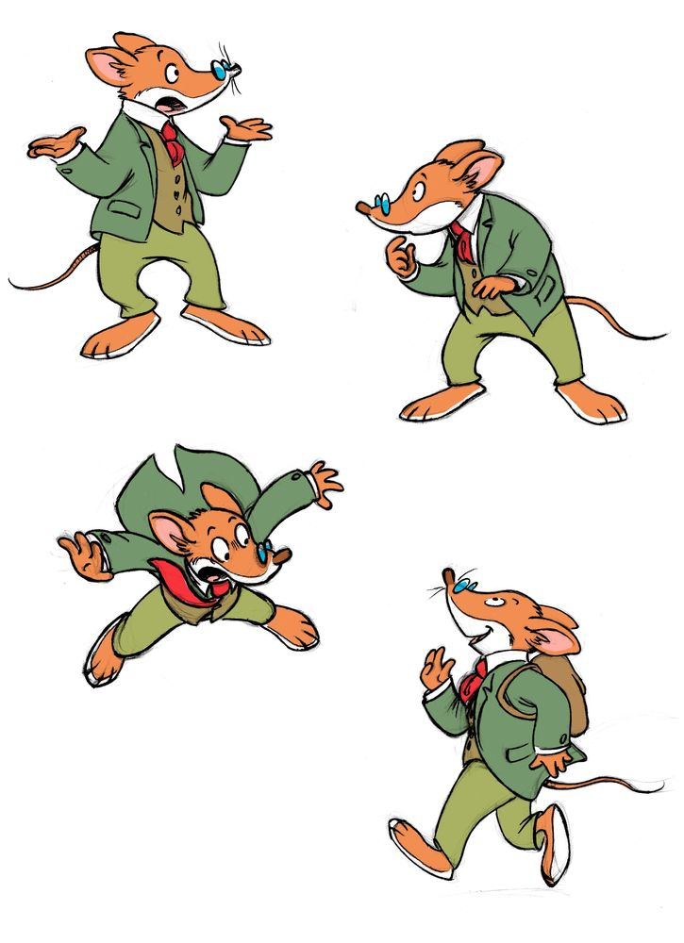](http://www.google.com/url?sa=i&rct=j&q=&esrc=s&frm=1&source=images&cd=&cad=rja&docid=7fbiMQ7pIo4ioM&tbnid=mXuDjdr0vfh8-M:&ved=0CAUQjRw&url=http://latribudepapel.blogspot.com/2011_11_01_archive.html&ei=j-2dUoGtKJC0kAetgYHQCw&bvm=bv.57155469,d.cWc&psig=AFQjCNFfXjTkX7K3JqUCzQfTTSjb93Zc4A&ust=1386166792306812)

Hmmm I have a good idea to tell [name].

Hey [name], if there is a game and you are afraid to lose..just tell your teacher you want to help. You could keep score or be the caller! I’m going to try that!

[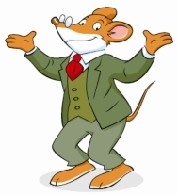](http://www.google.com/url?sa=i&rct=j&q=&esrc=s&frm=1&source=images&cd=&cad=rja&docid=VabptK4ltaimnM&tbnid=anXM1xn6eEHGGM:&ved=0CAUQjRw&url=http://www.licensingexpo.com/license-global/atlantyca-expands-geronimo-stilton-magazines&ei=nPSdUqCuNszLkAeF14HIBA&bvm=bv.57155469,d.cWc&psig=AFQjCNFfXjTkX7K3JqUCzQfTTSjb93Zc4A&ust=1386166792306812)

[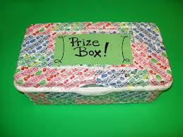](https://www.google.com/imgres?imgurl&imgrefurl=http://www.instructables.com/id/Back-to-School-Crafts-Prize-Box-for-Classrooms/&h=0&w=0&sz=1&tbnid=OpgUxrOAOmGmvM&tbnh=194&tbnw=259&zoom=1&docid=X8zaAWjW8V0dRM&ei=vPqdUvmQFZSvkAePh4HAAg&ved=0CAYQsCUoAg)[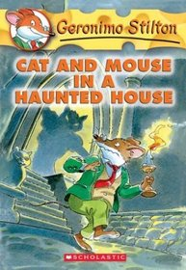](http://www.google.com/url?sa=i&rct=j&q=&esrc=s&frm=1&source=images&cd=&cad=rja&docid=eiThFF_BqcdsNM&tbnid=HU06WU7CDZtlTM:&ved=0CAUQjRw&url=http://www.paperbackswap.com/Cat-Mouse-Haunted-Geronimo-Stilton/book/0439559650/&ei=JPqdUrjYHZTqkAe_q4GwCA&bvm=bv.57155469,d.cWc&psig=AFQjCNHl3MsODkmUQJYIceeyZnWcG_5_1g&ust=1386171232689415)[](https://www.google.com/imgres?imgurl&imgrefurl=http://www.mycutegraphics.com/graphics/school/school-kids/student-using-computer.html&h=0&w=0&sz=1&tbnid=Rp63g7f4b5sofM&tbnh=224&tbnw=225&zoom=1&docid=1jnewELfKFdjcM&ei=sfmdUuHDHJG5kQfr-IC4Bg&ved=0CAIQsCUoAA)If you remember to do these things, I bet your teacher will be so happy! She might let you use the computer if you remember to do these things…She might let you read my books, she might give you a prize!

Here are the things:

1. If you win say: “Good game!”
2. If you lose STOP, take a breath, and say “I might win next time. Good game!”
3. OR..tell an adult: “I don’t want to play, I want to keep score or be the caller.”

[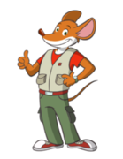](http://www.google.com/url?sa=i&rct=j&q=&esrc=s&frm=1&source=images&cd=&cad=rja&docid=VabptK4ltaimnM&tbnid=anXM1xn6eEHGGM:&ved=0CAUQjRw&url=http://librosfreehco.blogspot.com/2011/04/geronimo-stilton-temporada-1-completa.html&ei=ovadUqmcBobXkQfNp4DADw&bvm=bv.57155469,d.cWc&psig=AFQjCNFfXjTkX7K3JqUCzQfTTSjb93Zc4A&ust=1386166792306812)

You can do it [name] – try it and see!

**When I play a game this is what I do:**

1. If I win say “GOOD GAME!” to my friends.
2. If I lose I say “It’s OK Next time I might win, Good

Game!”

1. If I think I’m afraid to lose I can say, “I don’t

want to play, I want to keep score or be the

caller.”

If I do these things, my teacher

might let me

Use the computer, or read, or get a prize!

[](http://www.google.com/url?sa=i&rct=j&q=&esrc=s&frm=1&source=images&cd=&cad=rja&docid=VabptK4ltaimnM&tbnid=anXM1xn6eEHGGM:&ved=0CAUQjRw&url=http://librosfreehco.blogspot.com/2011/04/geronimo-stilton-temporada-1-completa.html&ei=ovadUqmcBobXkQfNp4DADw&bvm=bv.57155469,d.cWc&psig=AFQjCNFfXjTkX7K3JqUCzQfTTSjb93Zc4A&ust=1386166792306812)