[](https://www.google.com/imgres?imgurl&imgrefurl=http://hdbarbiedollwallpapers.blogspot.com/2013/05/barbie-doll-face-close-up-girl-games.html&h=0&w=0&tbnid=TE_i8oSMfilVGM&tbnh=222&tbnw=227&zoom=1&docid=3f7s3Q-5YcNeWM&ei=zmcnU5nDOpSB0QGmkID4Aw&ved=0CAgQsCUoAg)[](https://www.google.com/imgres?imgurl&imgrefurl=http://showstudio.com/blog/post/barbie_blog_meet_our_newest_face&h=0&w=0&tbnid=6W0qD5OvZGc1qM&tbnh=236&tbnw=214&zoom=1&docid=SYBUArQejbwlIM&ei=oWcnU6XzMKjk0gGLv4Fo&ved=0CA4QsCUoBA)

Good Job Suzzy!

Remember to use a Tissue!

Do you like hats?

Hi Suzzy – you are looking good!

Suzzy uses a tissue!

[](https://www.google.com/imgres?imgurl&imgrefurl=http://kattisdolls.net/KDold/faces/barbwh.htm&h=0&w=0&tbnid=5MyvTlaFQx9fGM&tbnh=212&tbnw=164&zoom=1&docid=tp25O0mTUfYWwM&ei=zmcnU5nDOpSB0QGmkID4Aw&ved=0CBEQsCUoBQ)

[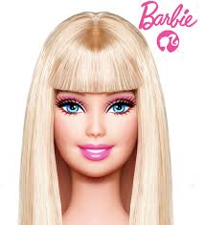](https://www.google.com/imgres?imgurl&imgrefurl=http://makeupforlife.net/2009/02/how-to-create-the-barbie-doll-makeup-look.html&h=0&w=0&tbnid=9d-kYuk7NaWMIM&tbnh=235&tbnw=214&zoom=1&docid=fWa3_6aeaPQF8M&ei=zmcnU5nDOpSB0QGmkID4Aw&ved=0CAUQsCUoAQ)

[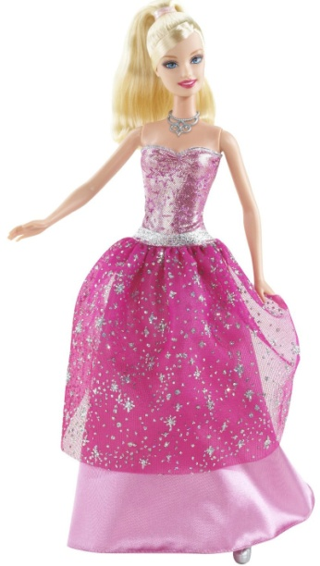](http://www.google.com/url?sa=i&rct=j&q=&esrc=s&source=images&cd=&cad=rja&uact=8&docid=htbcuKSED8jwIM&tbnid=oHpDQcL0_B_c0M:&ved=0CAYQjRw&url=http://mikemileski.blogspot.com/2012/05/why-were-more-playmobil-than-barbie.html&ei=rWgnU5X6CaaS0AG05YGgAQ&bvm=bv.62922401,d.dmQ&psig=AFQjCNFmavwix_i_0srHEZSICTi8GDdgcg&ust=1395177756794948)

[](https://www.google.com/imgres?imgurl&imgrefurl=http://www.examiner.com/article/kentucky-derby-101-history-of-the-derby&h=0&w=0&tbnid=ehF8blqIaeM0FM&tbnh=200&tbnw=196&zoom=1&docid=FWlqLPiSuAE-1M&ei=R2gnU_jQLYjI0QHp1YHQAQ&ved=0CA4QsCUoBA)

[](http://www.google.com/url?sa=i&rct=j&q=&esrc=s&source=images&cd=&cad=rja&uact=8&docid=nDW-TbRXiSceCM&tbnid=8Ydl7ylLh7Q7lM:&ved=0CAYQjRw&url=http://www.ebog.com/2d-platform-games/26/ultimate-flash-sonic.html&ei=jGknU6LsJarh0wHR1YHwDw&psig=AFQjCNHjT6BqxV-6sPmx3s_HBhgVaRvPKQ&ust=1395178102540645)

[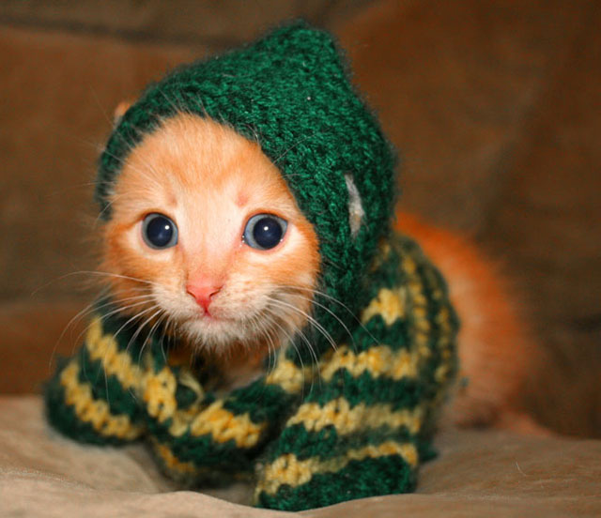](http://www.google.com/url?sa=i&rct=j&q=&esrc=s&source=images&cd=&cad=rja&uact=8&docid=xXpWSqI3f5JPlM&tbnid=mB3V3XhR6PHcYM:&ved=0CAYQjRw&url=http://www.getupanddosomething.org/click-to-calm-cute-kittens/&ei=aGonU_iTJq3C0AGV-YGIAw&psig=AFQjCNHjT6BqxV-6sPmx3s_HBhgVaRvPKQ&ust=1395178102540645)

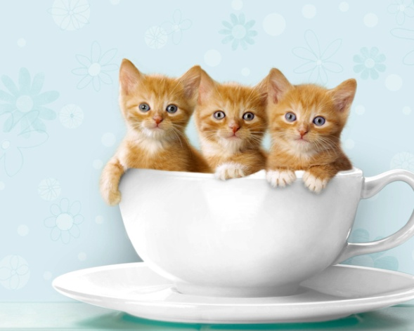

[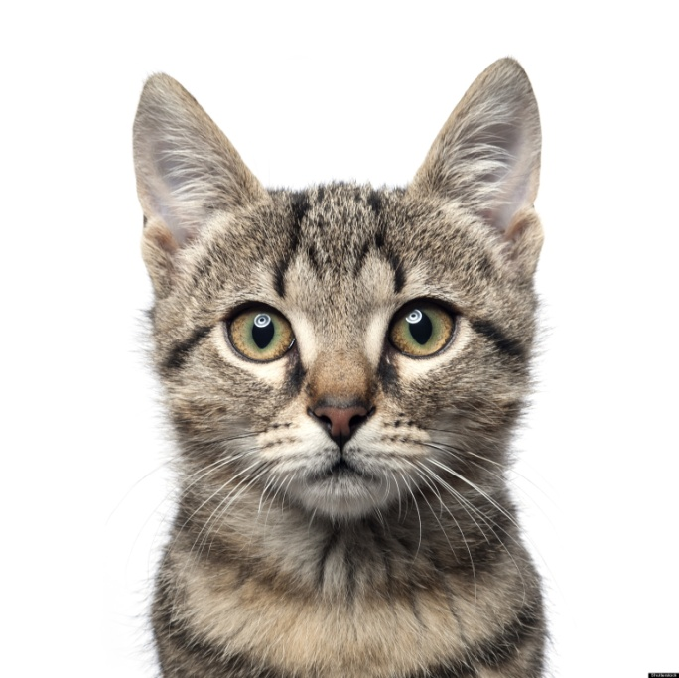](http://www.google.com/url?sa=i&rct=j&q=&esrc=s&source=images&cd=&cad=rja&uact=8&docid=mZ9pi4PbcfADPM&tbnid=1mzKXkCMuAzlsM:&ved=0CAYQjRw&url=http://www.huffingtonpost.com/2013/01/30/domestic-cats-kill-billions-mice-birds-annually-study_n_2575833.html&ei=G2snU_bYI-PO0gHd_oCYDw&psig=AFQjCNG-8dF_Bwbnn71YQYMtQTlpA58PwQ&ust=1395178558827317)

[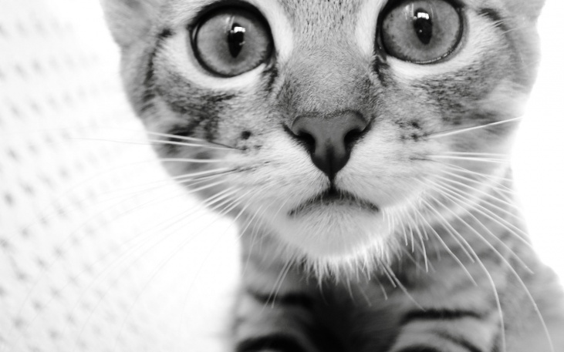](http://www.google.com/url?sa=i&rct=j&q=&esrc=s&source=images&cd=&cad=rja&uact=8&docid=mZ9pi4PbcfADPM&tbnid=1mzKXkCMuAzlsM:&ved=0CAYQjRw&url=http://www.fanpop.com/clubs/cats/images/32040775/title/cat-wallpaper&ei=y2onU5-1JqGR0AHW7YDwCg&psig=AFQjCNG-8dF_Bwbnn71YQYMtQTlpA58PwQ&ust=1395178558827317)