
Recess

Some days I have indoor recess and some days I have outside recess. When I have outside recess, I go to _______’s room before I go out to play. In __________’s room, I read a social story about play with friends, dealing with being upset, or playing outside. After I read my social story, I go outside for recess.

Recess can be a lot of fun, but sometimes I can get upset. If I get upset, I can tell _______, _________, or a teacher on recess duty. I can ask for a break. I can come back to _________’s room with _________ or __________.

If I get upset during recess I will try to __________________________

________________________________________________________

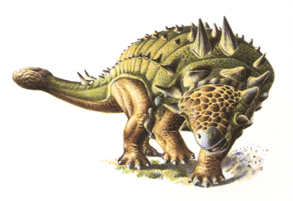
Sometimes I get upset when I play with Triceratops. I can take a break and go to _______’s room to calm down. Then I know I won’t touch my friend and hurt him!

