
QUIET PLEASE!

There are a lot of children in my classroom.

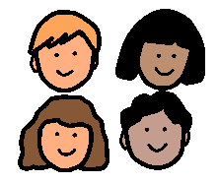

My teacher talks to all the children.

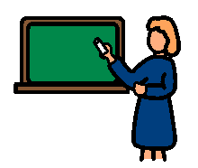

When it is noisy in the classroom, the children can’t hear what the teacher is saying.

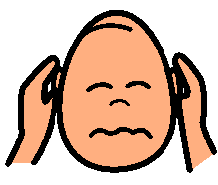

When it is noisy in the classroom it is easy to get confused and frustrated.
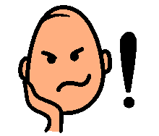

When I talk out loud, it is noisy! When I yell it is too noisy!

I will try to talk quietly.

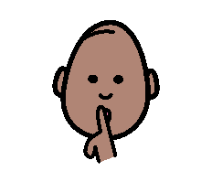

I will try to raise my hand and wait until my teacher calls on me.
