
Country Music Stars
Keep Their Cool!

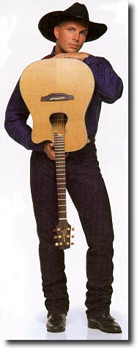
Sometimes Country Music Stars have to work hard to keep from saying some mean words. When one of Garth Brooks’ fans makes too much noise, or bothers him while he is on stage, sometimes he wants to say something very mean. But, he doesn’t. He “keeps his cool”. Keeping his cool means that he looks the other way and ignores that mean person. He doesn’t say mean words to them. He tries not to say anything at all to that person.

Garth Brooks keeps his cool.

Kenny Chesney keeps his cool, too.

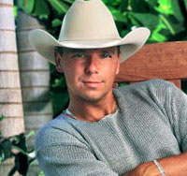
When someone is bothering him, he looks away or walks away and ignores them. He knows that saying mean words will not help! Sometimes saying mean words will get him into more trouble.



Even the Dixie Chicks get mad at people sometimes. When someone bothers one of the Dixie Chicks, she looks away or walks away. Saying mean words will only get her into trouble. That’s not cool!

The Dixie Chicks keep their cool!

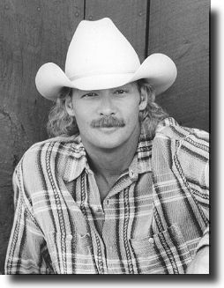
Keep your cool xxxxxx.

Alan Jackson keeps his cool! He wants you to keep your cool, too.

When other kids bother you or make you mad:

Look away
Walk away
Keep your cool

Remember that saying mean words can get you into trouble.

When it’s very hard to keep your cool, here are some things you can try.

Say something that is not mean, like,
“I really don’t like that.” Then, walk away.
Or
Take 3 deep breaths to help you calm down,. then walk away.
Or
Walk straight to an adult and talk it out.



Toby Keith and Tim McGraw “keep their cool” when someone bothers them. They want you to remember to:

Look away or walk away.

Don’t say mean words.

Take deep breaths to stay calm.

Talk it out with an adult.

Keep your cool!!

