
Work Like the Steelers!

Going to school is like being one of the Steelers. You go to school each day and they go to Heinz Field.


When you get to school you have to follow your schedule. Your teacher has different things she needs to teach you. When the Steelers get to the field they need to follow a schedule too and listen to what Coach Tomlin has to teach them.



At school and at practice it is important to do your best.

Most of the time you need to do work that the teacher has prepared for her students. Troy and Hines have to practice too. They have to work on the plays the coaches tell them to practice.



If you work hard and get your work done you might have choice time. You can take a break from work and do something fun!

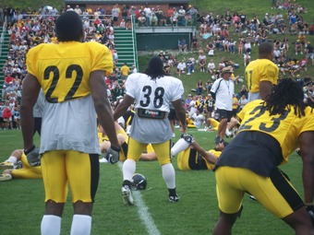

After working hard at school and practicing hard it is choice time. You can choose something fun to do like talking to friends or using the computer or playing a game.

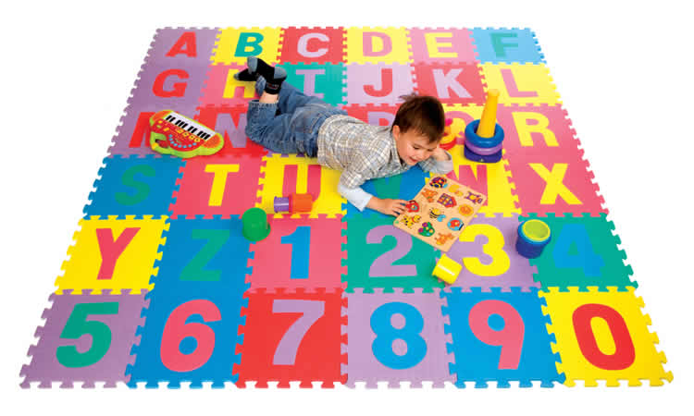

After choice time it is back to school work and practice. The Steelers need to be ready for the games and students need to be ready to take assessments and tests.

Try to remember that going to school is like being one of the Steelers. You work hard and do your best each day just like Hines and Troy.
All you students-
Work Hard.
Do your Best.
Be a Winner!

Go Steelers!

