
When I Raise My Hand
My name is ________________. I go to __________________
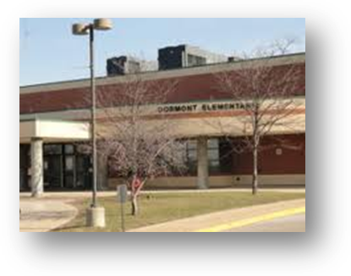
Elementary School.

I am in _________ grade.
When I am in my classroom my teacher asks questions. I love to raise my
hand. I want the teacher to call on me.
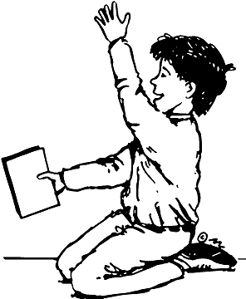

When the teacher wants to give someone a turn I want the teacher to call
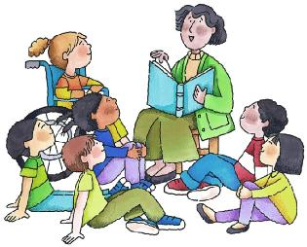
on me first!
Let’s see who I’ll call on next…

But…uh oh…guess what! Other kids want a turn too! My teacher is trying
hard to give everyone a turn. Everyone cannot be first!
It does not matter who goes first – I give everyone turns!

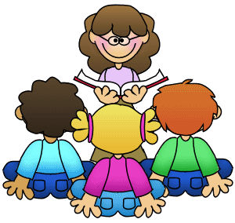
I want her to call me first!
I hope she calls on me first!
Ooooh, I hope I am first!

T

The MOST IMPORTANT thing is that everyone gets a turn during the day.
If I don’t go first that is OK. I don’t want my teacher to be sad that she did
not call on me first. I’m going to tell her that is OK – I know she will call on
me sometime too.

I might even help my teacher to know who she called on – I can check for
her on a chart like this!

The teacher called on ________

I’m going to try and make my teacher happy. I know she will give me a
turn, I know she will call on me. I just don’t have to be first and that is OK!
I’m going to try hard to be OK when I don’t get called on first. I can do it!


