
What is a Lockdown Drill?

Sometimes we have Fire Drills.
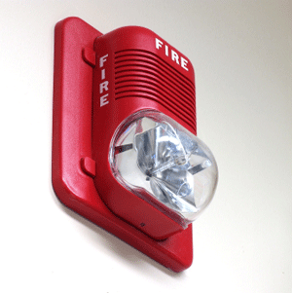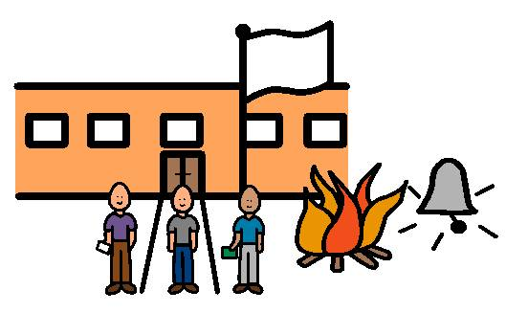

Fires almost never happen in schools, but, just in case, we practice what to do if there is a fire. That keeps us safe!

Sometimes we have Emergency Weather Drills.

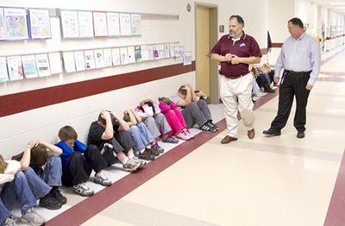

Tornados and other weather emergencies almost never happen in school, but, just in case, we practice what to do if there is a weather emergency. That keeps us safe!

There is a new type of drill at our school this year. It is called a Lockdown Drill.

A lockdown drill is to practice what to do if a there is an intruder in our school.

An intruder is a person who is not supposed to be in our school. When someone is in our school who is not supposed to be there, our teachers and principals want us to stay safe.

Intruders almost never come into schools, but, just in case, we need to practice what to do. That will keep us safe!

When there is a lockdown at our school, there will be an announcement over the loudspeaker. Someone will say, “The school is in lockdown, please secure your rooms”.
Our teachers know just what to do. We will stop and listen to our teachers.

Our teacher will let us know where to go. Our teacher will lock the door to keep us safe.

Our teacher will turn out the lights.

Our teacher will keep us away from the door and the windows. We may need to crowd together against a wall or in a corner. We will need to be very quiet.

When the principal checks everything out and decides that the building is safe, an announcement will be made. Someone will say, “The lockdown is over. The building is secure”.

A lockdown drill is a way for us to practice being safe.

