What Kids Expect – and What They Don’t Expect

In school, there are many kids in classes. Kids go to school ‘expecting’ their classmates to act a certain way.

They expect kids to
Smile

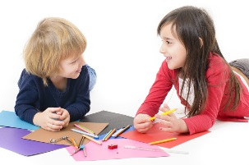
Make conversation about things they might be interested in

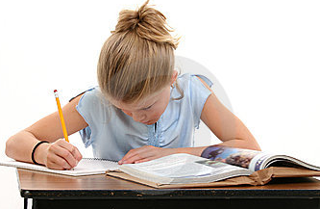
To do their work quietly
Not to bother others

Something kids DO NOT EXPECT (that is called UNEXPECTED BEHAVIORS) is:
When a kid talks out really loud in class!
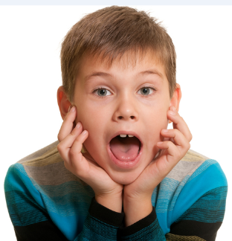
AHHH why did _____yell: “I’m not finished” so LOUD. It hurts my ears

Oh my! That scared me when _____ just talked out loud without raising her hand! I did NOT EXPECT it!!!
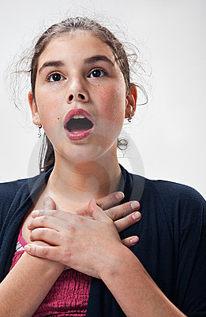

Sometimes I just get worried and I yell out loud. If I think I am behind, or if I spell a word wrong I just yell!
WAIT STOP!!!

But kids EXPECT me to RAISE MY HAND first. Then they won’t be surprised or scared. They EXPECT me to TALK QUIETER
I’m upset but I’m trying to raise my hand and talk quiet
SHH I’m trying to talk quietly

If I do what kids EXPECT then we will all be happier!
Yea _____talked quietly
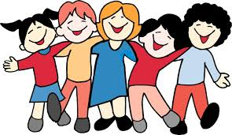
YEA _____raised her hand to talk!

