
Sticky Thinking

Sometimes I get a thought stuck in my mind. I think about it over and over.

I didn’t get the grade I wanted
I need to be ahead of everyone
I can’t do this work

I try to start my work, but I keep thinking about the same thing! This is called “STICKY THINKING”.

The good news is that I have control over my sticky thinking. I will try to look at my sticky thought as a yellow post it note. Some people call post-it notes “Stickies”. The note is hanging on the wall in my mind.
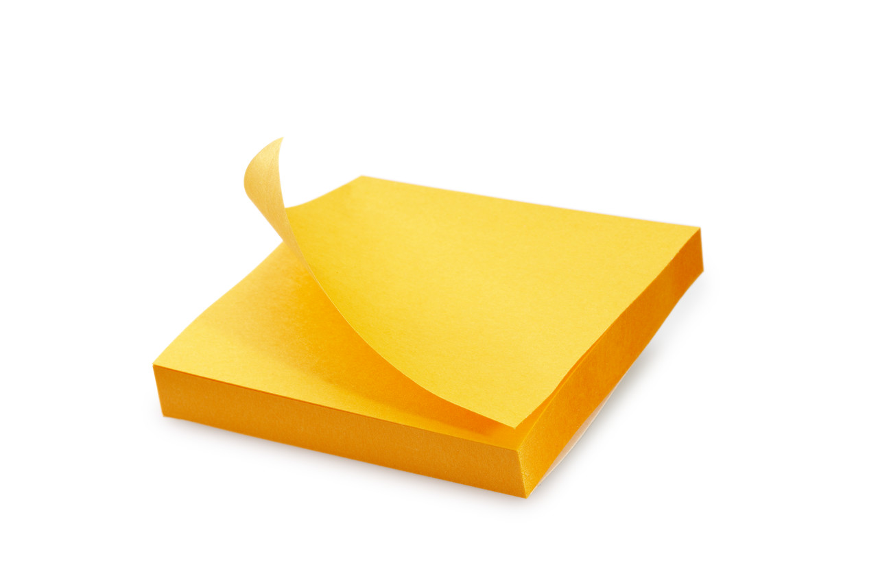

I can pull the note down and throw it in the trash! Now my sticky thought is all gone. I can get back to work. I HAVE CONTROL OVER MY STICKY THOUGHTS!!


And one more cool thing. I could even write my sticky thought on a real post it and throw it away in the real trash!! I can’t wait to throw my sticky thoughts away!

