
Sometimes Kids Whisper

In school, our teachers want us to use quiet voices.

When we use quiet voices, everyone can hear what the teacher is saying.


Sometimes, when a friend is trying to help, she will whisper. This is a way to help a friend, but still be able to hear the teacher.

Whispering means to use a very quiet voice.

Sometimes it’s OK to whisper to each other in school. This helps to keep the classroom calm and quiet.

If someone whispers to you and you can’t hear, just get a little bit closer and quietly say, “What did you say?”
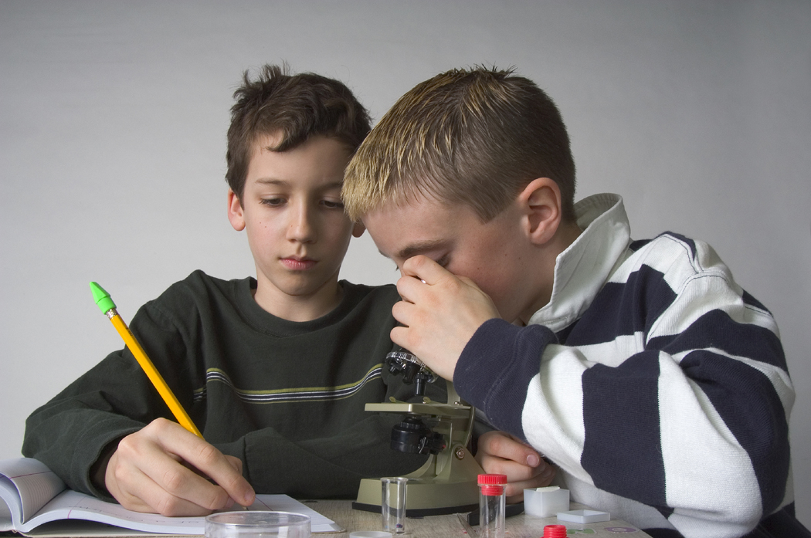
What did you say?
This will help keep the classroom calm and quiet.

