
Someone is Crying

Sometimes in school, someone in my class cries.



Maybe they don’t feel we well.

Maybe they got hurt.

Maybe they feel sad.

When someone is crying, I can say,
“Are you OK?” or
“What’s wrong?”


When someone is crying, I don’t have to cry.

When someone is crying, I don’t have to be sad.

When someone else is crying, I will try to keep working.
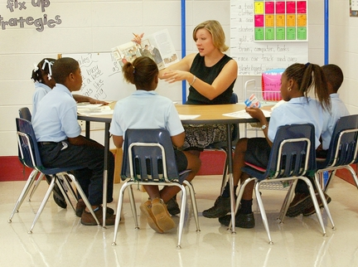

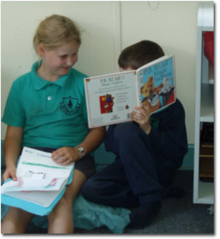
If I need to, I will ask the teacher if I can move to a quiet place in the room.

