My name is _____ and I go to _______ Elementary School.

I am in 3rd grade and my teacher’s name is ____ ________

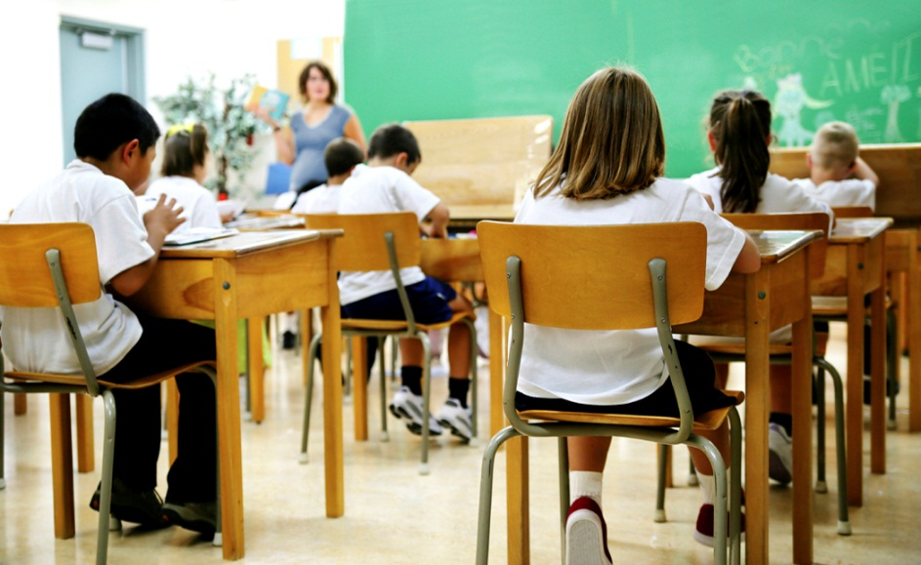

I like going to school and learning new things. I have lots of friends at school.



Sometimes children in my school get sick.

C:\Users\Claudia\AppData\Local\Microsoft\Windows\Temporary Internet Files\Content.IE5\ODLCMGW2\MC900423834[1].wmf

When children are sick they have to stay at home. Everyone gets sick sometimes.

.C:\Users\Claudia\AppData\Local\Microsoft\Windows\Temporary Internet Files\Content.IE5\WB3GBRPG\MC900359007[1].wmf

When you are sick and stay at home you get to sleep late, use the computer, watch TV and play with games and toys.

When children feel all better they are allowed to go back to school.

That is the school rule -

**Sick children are not allowed in school until they feel better!**

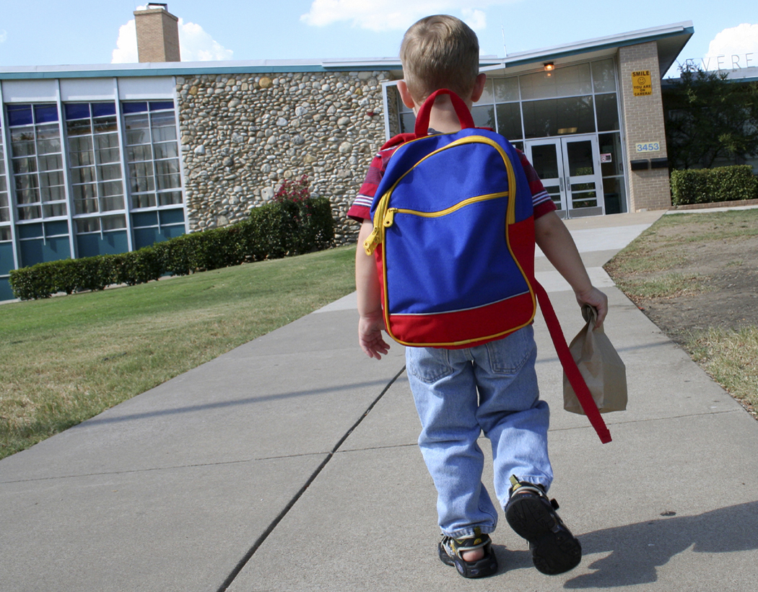

Sometimes when children are sick they miss a couple days of school. They may miss some work and other things that happen at school.

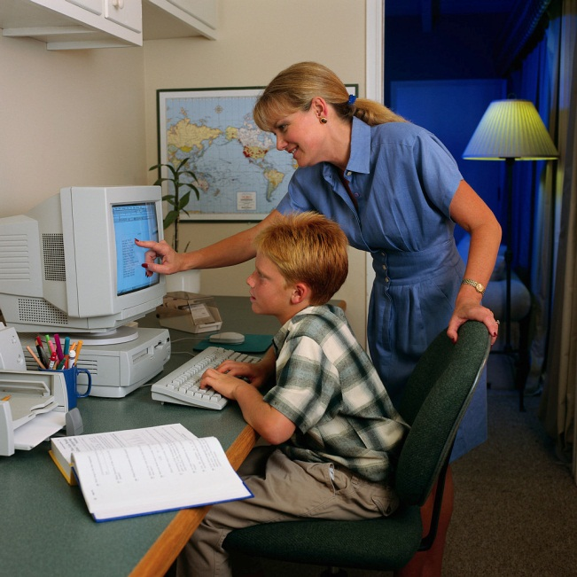



C:\Users\Claudia\AppData\Local\Microsoft\Windows\Temporary Internet Files\Content.IE5\HHE47FBM\MC900424466[1].wmf

It is okay if you miss some of your work at school when you are sick. Everyone misses some work at school when they are sick.

The school rule that no one goes to school when they are sick means that sometimes you miss work. And that is **OKAY**!

C:\Users\Claudia\AppData\Local\Microsoft\Windows\Temporary Internet Files\Content.IE5\ZZG48IUS\MC900057117[1].wmf

Your teacher will help you make up the work you miss when you are at home sick. She will tell you to go slowly and do a little bit at a time.

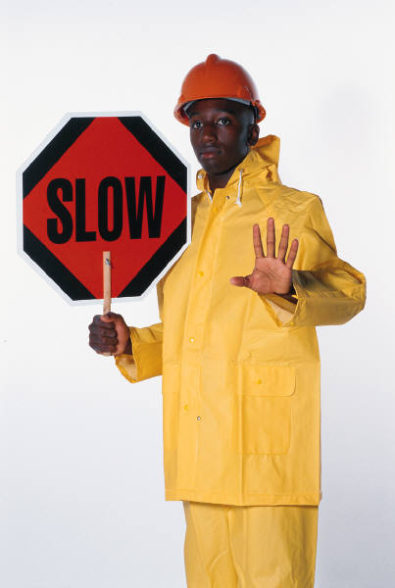

Don’t worry, everyone makes up their work a little at a time. It is easy to do.



C:\Users\Claudia\AppData\Local\Microsoft\Windows\Temporary Internet Files\Content.IE5\NKWFVAPJ\MC900442036[1].wmf

Try to Remember

1. It is okay to miss some work when you

are sick.

2. Your teacher will help you.

3. Go slowly and do a little at a time.

4, Everyone gets sick sometimes. It is not

your fault.

It is okay! C:\Users\Claudia\AppData\Local\Microsoft\Windows\Temporary Internet Files\Content.IE5\0AFEJFZ8\MC900098039[1].wmf

Sometimes Kids Get Sick and Miss Work at School

C:\Users\Claudia\AppData\Local\Microsoft\Windows\Temporary Internet Files\Content.IE5\ODLCMGW2\MC900423834[1].wmf