
PLAYING THE FRIENDSHIP GAME

When we play games with our friends, we are actually playing two games at the same time. We are playing the sport or board game or card game:



And, we are playing the FRIENDSHIP GAME.

When you play sports or other games, winning and losing is often just chance – you are in the right spot at the right time – or you, by chance, pick the highest card or roll the highest number on the dice. It’s just luck or chance.


When you are playing these two games, there are four ways the games can go.
- Win the game and win the friendship game
- Win the game and lose the friendship game
- Lose the game and win the friendship game
- Lose the game and lose the friendship game.

Let’s think about each of these “outcomes”:

Win-Win

It is so much fun to win a game. But, when you win at a sport or board game, you have to be a good sport to also win at THE FRIENDSHIP GAME. What are some things you should remember about being a good sport when you win?

__________________________________________________________________________________________________________________________________________________________________

Win – Lose

If you cheat or are not honest in a game, you might win the game, but you will lose THE FRIENDSHIP GAME . Even if you win the game, you could lose THE FRIENDSHIP GAME if you laugh at or make fun of your friends that lost at the sport or board game.

Lose – Win

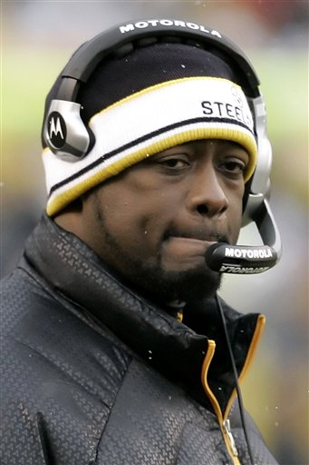

Even when the Steelers lose, Mike Tomlin shakes hands and congratulates the other team’s coach. He is winning THE FRIENDSHIP GAME.

When you lose the sport or game, you can still win THE FRIENDSHIP GAME.
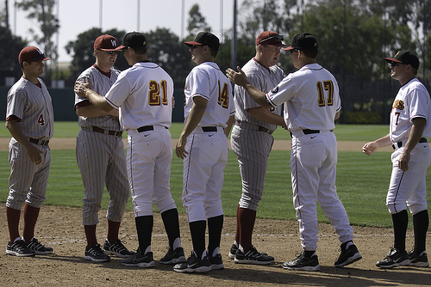

What are some things you can do to win THE FRIENDSHIP GAME when you lose a game?

__________________________________________________________________________________________________________________________________________________________________

Lose – Lose

It is no fun to lose a game. But, if you lose a game and you are also not a good sport about it, you could lose THE FRIENDSHIP GAME, too. If you lose a game, it is important to congratulate the other players so they will want to play the game again. You might be a little upset, but you can say something respectful to the other players:

Oh, well – Nice game!
You really played well, rematch tomorrow?

If it is too hard to say something kind because you are upset, it is better to walk away quietly and ask your teacher for a break. Don’t say something you will regret later.

Win the Friendship Game:
Be a good sport:
Honest
Fair
Congratulate others when they win and be a good sport when you win, too!

