
Nose Picking

People have noses.
I don’t like how it feels to have snots in my nose.

Sometimes I pick my nose to get rid of the snots or because I am anxious.
The kids in my class think this is really gross and may be thinking “that is sick” “yuck” or stay away from me. This would make me feel upset and lonely.

Instead of picking my nose I can:
Get a tissue
Blow my nose
Then I throw out my tissue. It is best to wash my hands when I’m done.
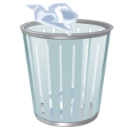
OR
If I’m picking because I am anxious, I can do something else with my hands like:
Make a fist and count to 10. 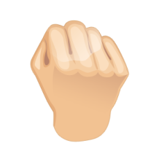
Use a fidget item. 

Ask my teacher for a break.

If my nose is still bugging me and I HAVE to pick it, I need to go somewhere private, like the bathroom.


Then I HAVE to wash my hands very well!

I feel much better when my teachers or classmates do not think I am doing something disgusting. I feel better when I can blow my nose or play with a fidget item instead. It makes my teachers, classmates and family happy too!

