
Making Good Decisions
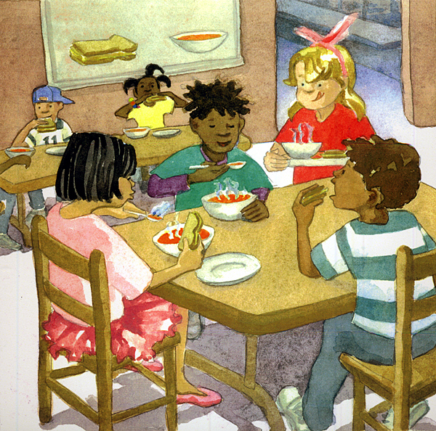
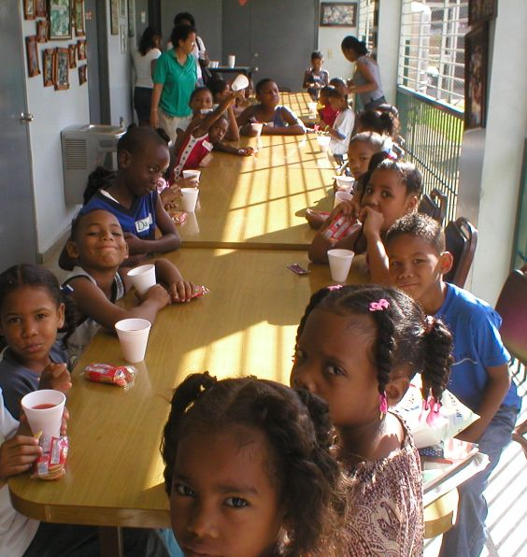

We go to school every day and make decisions. We decide what to eat at breakfast and lunch.

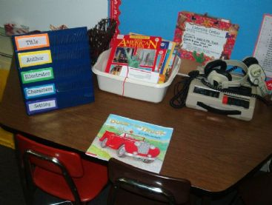

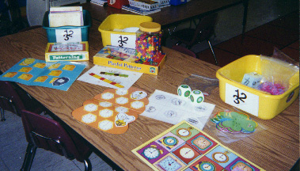

We decide what games to play at center time. We decide what books to read and what to draw. These are good decisions. They are good for us and good for those around us.



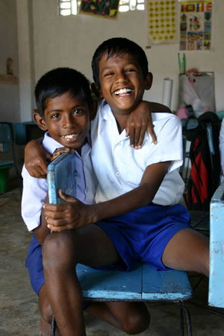

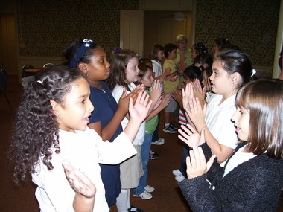

In school it is a good decision to say nice things to our classmates. When we say nice things it makes the other person happy.

Sometimes at school things happen that can make you angry or scared. When this happens it is a good decision to talk to an adult. They can help.

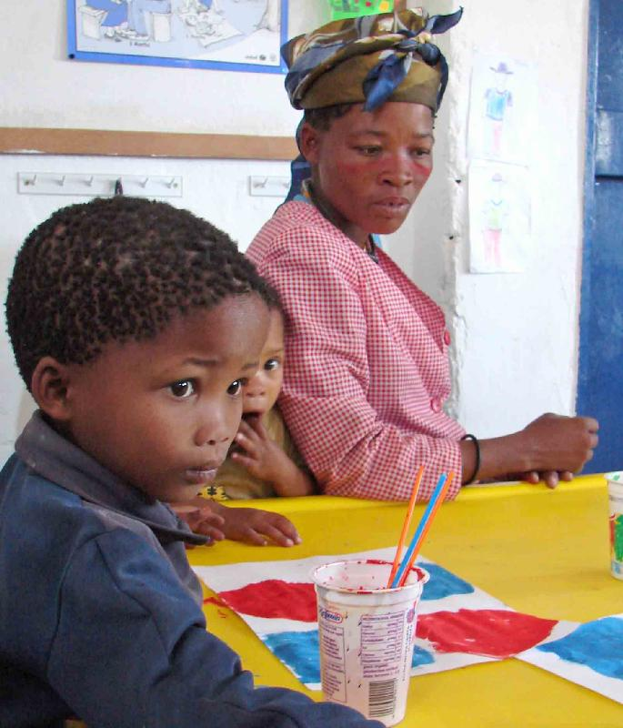
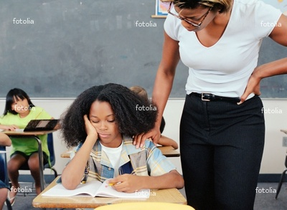

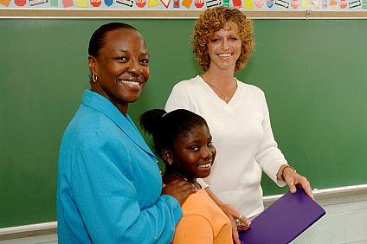

There are things you can do when you are angry or scared. An adult can help you calm down and help fix what is making you angry or scared.

Sometimes kids make bad decisions. They might say mean things to another kid and make them feel sad and scared.



Sometimes when people are sad and scared they make bad decisions. Bringing a gun to school is a bad decision. That is dangerous for everyone! Bringing things to school that might hurt someone is a bad decision.

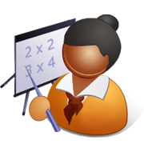

If we hear about someone bringing something dangerous to school we should tell an adult. If we hear someone saying mean things to someone we should tell an adult. It is a good decision to tell an adult if someone is being mean or if they brought something dangerous to school.

So remember to make good decisions. Use nice words with classmates. Tell an adult if someone is mean or has something dangerous. This will make your teacher happy and you will be happy too.

Remember to Make Good Decisions
*use nice words
*talk to adult when angry or scared

Remember to tell an adult
*if someone says mean things
*if someone brings something dangerous to school

