
MAD, MAD, MAD

My name is ______ and I attend ______ Elementary School.
There are many things that I really like at school. I love _________.

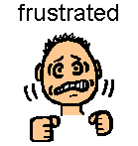
Sometimes things bother me in school so much that I feel very mad! Sometimes I get mad if someone gets near something I made with blocks. Sometimes I get mad when Miss _____ doesn’t call me first. …. When that happens I feel so mad I have to do something! Sometimes I pinch or scratch. But this is not a good thing to do. It can really hurt someone. I don’t really want to hurt someone. I just don’t know what to do when I feel so mad.

Other people around me have the exact feelings at different times. I can't believe it but it is true. Sometimes Ms. _____gets mad. She has lots of kids to teach and sometimes the schedules don't work and she has the same feelings I do. When she feels this way she breathes deeply 3 times. Then she counts to 10. Then she finds someone to talk to about her feelings. Sometimes another person can help her.

Sometimes Mr. _____ feels frustrated. He feels this way when he feels this way he lays down so he can calm down. Then he asks another adult to help him out.

Ms. _____ gets mad too. When she gets mad she squeezes a “squeeze ball” that she keeps in her pocket. Then she talks to someone to get help.

Someone wrote a book about a boy gets mad like me. When he feels mad he does exercises called "Anxiety Busters". Anxiety is another word for a mad feeling. They are exercises that you do to get rid of feelings when you feel mad. He calls them "starts and stops". You "start" by squeezing or stretching part of your body really hard. Then you count to five and then you "stop". The part of your body that was squeezed or stretched relaxes and you feel better. You do it all over your body. You can follow pictures and count exactly to five each time. These pictures are attached to this story.
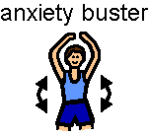

So there are many things I can try when I am feeling mad. Here is a list of what I can do to feel better:
- Think of how my body feels. Sometimes my body is shaking, or my muscles are tight. I feel like pinching or scratching.
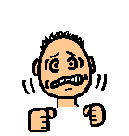
- Next I think of a word to call the feeling like "mad, or angry, or upset" then I can tell an adult.
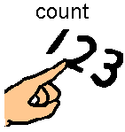
- Next I stop! Then think of things I can do. I can count to 10.

I can breathe deeply 3 times and blow it out.
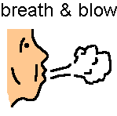
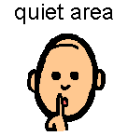
I might want to tell the adult I need to walk away or go to a quiet area.

I might do a relaxation exercise like the Anxiety Busters.

I might squeeze a squeeze ball that is in my pocket.

- Finally, I can try to talk with an adult about my problem and what else I can do to solve it.
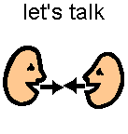

Here are some pictures of me trying all these things when I feel mad.
When I try these steps I will feel better and figure a way to solve my problem. I will have a lot more good days at school. I think I will try to help myself when I feel mad. Then I will feel better and so will everyone at school.

Getting Mad

