
Look so everyone can hear me ☺

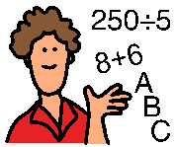
My name is _______. I go to _______ Elementary School. My teacher is Mrs. _______.


I like my school! I sit right up front. Sometimes Mrs. _______ asks the class questions. I raise my hand to answer. She calls on me and that makes me happy!


When Mrs. _______ calls on me I answer her every time. Sometimes when I answer I look towards Mrs. _______ then she can hear me.

Sometimes I turn around and answer. But then Mrs. _______ can’t hear my answer.
What did you say _______? I can’t hear you

I’m going to try and remember to turn my body TO Mrs. _______ and look at her or look near her so she can hear me.
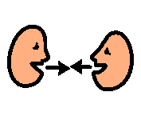


She will like to see my face and hear my voice! Then we can smile at each other too!

