
Let’s All Work Together!

There are a lot of children in my classroom.
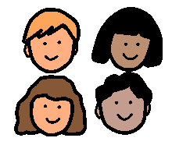
My teacher talks to all the children. She teaches us many things every day.
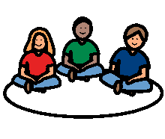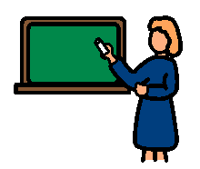

The students listen and follow directions. We work together to learn and participate in class.

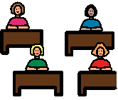
Sometimes our teacher asks us questions. The students raise their hand when they know the answer. Our teacher will call on someone to answer. That is participating in class!

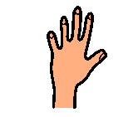

Sometimes we take turns reading or writing on the board. The students raise their hand to get a turn. The teacher calls on someone to read or write on the board. That is also participating in class!

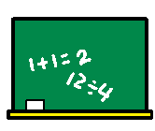

I will try to remember to raise my hand to participate during class. This will help me learn more. It will help us all work together.

Sometimes our teacher gives us a paper or other work to do at our desks. The students should get busy right away and finish the assignment. That is participating in class, too!



I will try to remember to raise my hand and to complete all of my work. That is participating. When we all work together, we will learn so much more!

