
It’s OK When You Don’t Win

Sometimes kids play games. They might play games in school like during gym class or at recess. Sometimes they might play games in the classroom for indoor recess or to learn something like playing a math game.
When kids play a game someone wins and someone loses. When a kid loses a game he might have different feelings. He might feel frustrated.
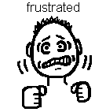
Or he might feel very sad.

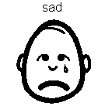
It’s OK to feel this way BUT…the kid also knows that it is OK to lose sometimes. The most important thing is playing the game with a friend and having fun while playing the game.

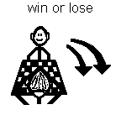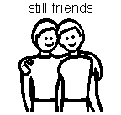
Even when a kid loses a game he is still nice to the person who won and still likes him for a friend. Kids like other things in life too. That is what makes it OK to lose a game because winning isn’t the most important thing.
When you lose a game you can say things like “I thought I would do a little better but I have to be happy with what I did.” Sometimes you can say to the person who won, “You are a good player!”
The most important thing is to still be friends and enjoy the game.
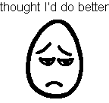

So kids need to remember:
1. It’s OK to feel sad or frustrated if you lost.

- It’s OK to lose sometimes.
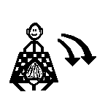
- If you lose say to yourself, “I thought I’d do better but I’m happy with what I did.”
- If you lose say to the winner, “You’re a good player!”

- And remember, the most important thing is playing, having fun, and having friends!

I’m going to try and do the 5 points. I’ll let my teachers know about them. Doing the 5 points is what makes good players and good sports! If I can do the 5 points I will feel proud of myself and so will my teachers!



