
Hair Pulling
Sometimes when I am working at school, I feel like touching the hairs on my eyelashes or eyebrows. I like to pull the hairs and play with them in my fingers. I feel like I just can’t stop doing it.

Sometimes when a person feels like they can’t stop themselves from doing something, it’s a good idea to come up with a substitute for the behavior.

For example, if you feel like pulling on your eyelashes, squeeze your hands together very hard instead. Try to count to 10 while you are squeezing your hands together.
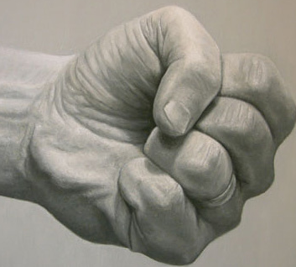 12345678910
Or, if you feel like pulling out little hairs from your eyebrows, pull out a little hair from a paint brush instead.

Or, rub your fingers on a piece of rough velcro that is on your binder.
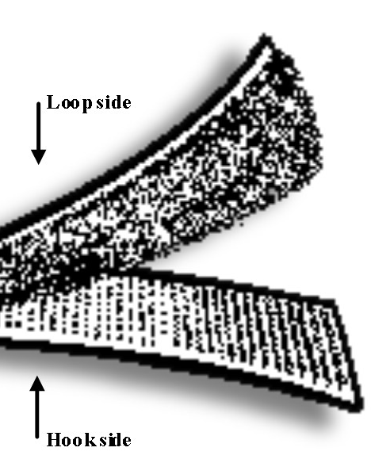
Always try to think of something else to do with your hands so you won’t be tempted to pull out the hairs from your eyebrows or eyelashes.

Which strategy will you try?

