
Friends at School

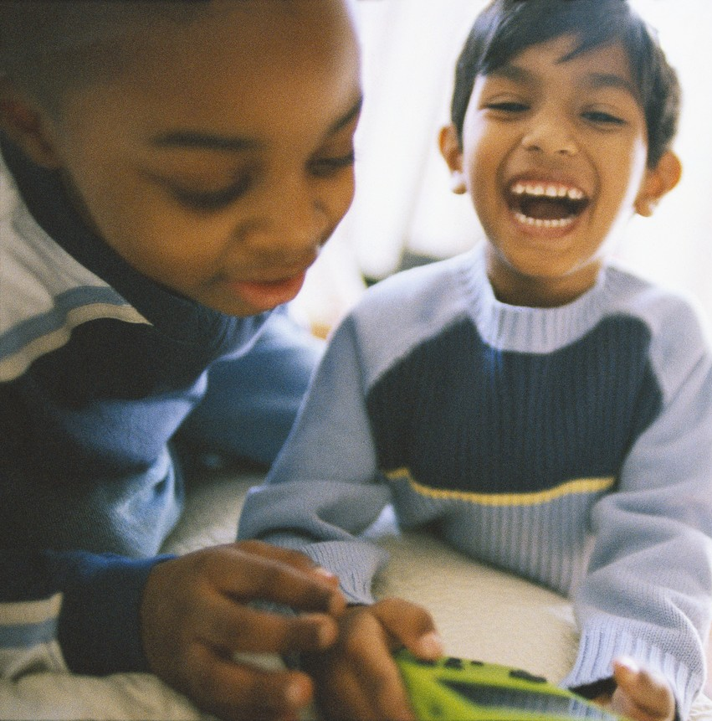
A friend is someone that you like to be with. A friend plays with you and laughs with you.
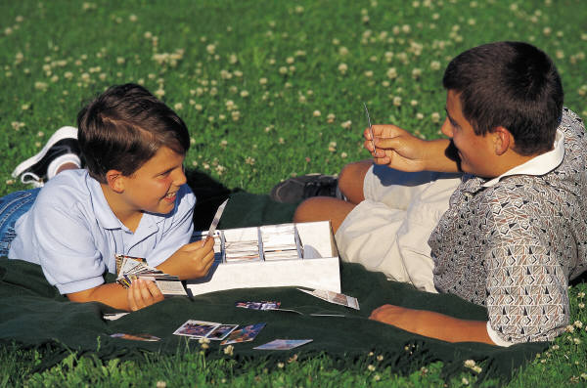
A friend is someone who will talk with you and share with you.

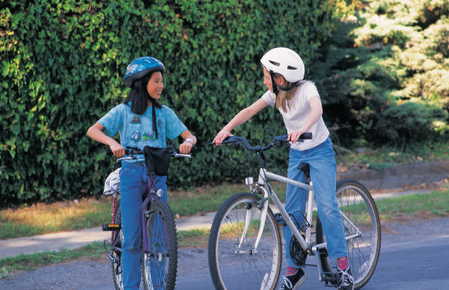

Do you think these kids are friends?
They are talking on the school bus. They are being friendly.

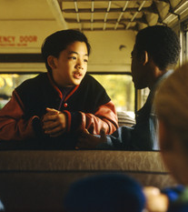
These kids are friends!

Do you think these kids are friends? They are having a snack together. They are looking at each other and laughing.

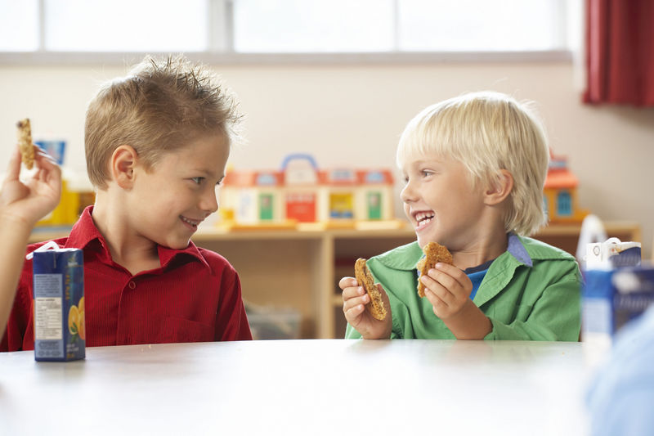

These two boys are friends!
Friends listen to each other.

If a friend says to you, “Please stop doing that, I don’t like it.” Should you listen?
Please stop doing that!

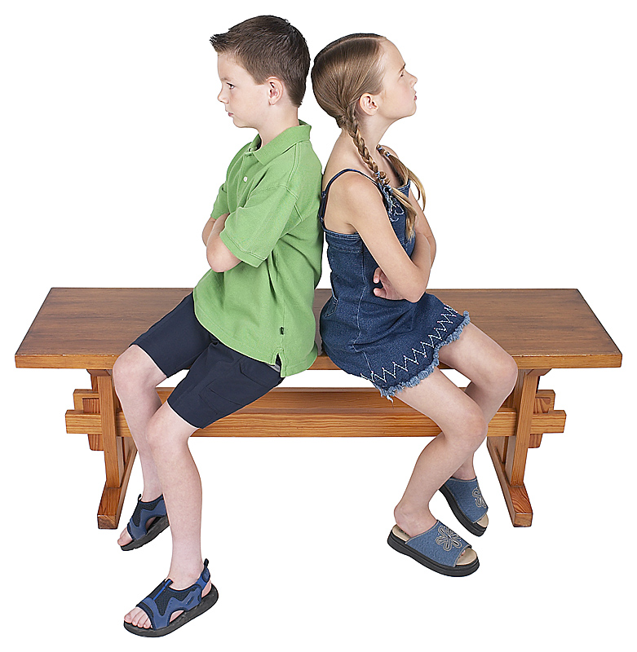
Yes, you should. A good friend does not hit or tease.

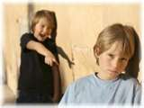

If you hit or tease, other kids will not want to hang out with you.
No one wants to hang out with me.

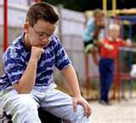

Try to listen to your friends. When they ask you to stop doing something, you should stop. Try talking, playing, and telling jokes instead.

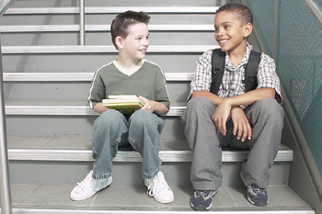
Then you will have lots of friends at school!

