


FRUSTRATIONS, FRUSTRATIONS

FRUSTRATIONS, FRUSTRATIONS!!

My name is __________ and I attend ________ School. There are many things that I really like at school. I love computers. Many times we do projects with the computer in the lab. Right now I am working on a report about ________.

Insert picture of child on the computer here.


Sometimes school is difficult. Sometimes I might not understand the school work. Other times things just bother me. For example, sometimes I ask a question but people don't seem to understand what I am talking about. That can get very, very frustrating.

No matter how hard I try they still don't understand what I am asking. When that happens I feel like screaming or throwing things. But this is not a good thing to do.

Other people around me have the exact feelings at different times. I can't believe it but it is true. Sometimes Ms. _______ feels frustrated. She has lots of kids to teach and sometimes the schedules don't work and she has the same feelings I do. When she feels this way she breathes deeply 3 times. Then she finds someone to talk to about her feelings. Sometimes another person can help her.

Insert picture of teacher here.

Sometimes Ms. ________ feels frustrated. She feels this way when she has to drive her own kids to many different places, work all day, then get home and cook dinner. When she feels this way she lays down for 10 minutes.

Insert picture of teacher here.

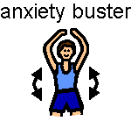
Someone wrote a book about a boy who has bad days like me. When he has a bad day he does exercises called "Anxiety Busters". Anxiety is another word for frustration. They are exercises that you do to get rid of feelings on a bad day. He calls them "starts and stops". You "start" by squeezing or stretching part of your body really hard. Then you count to five and then you "stop". The part of your body that was squeezed or stretched relaxes and you feel better. You do it all over your body. You can follow pictures and count exactly to five each time. These pictures are attached to this story.

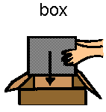
In my classroom I have a ? box and a declarative box. I can use these too when I feel frustrated. I can write a sentence about what I want or how I feel. I write questions. I put my sentences or questions in the box then someone will read them and get back to me.

So there are many things I can try when I am feeling frustrated or full of anxiety.

Here is a list of what I can do to feel better:
- Think of how my body feels. Sometimes my body is shaking, or my muscles are tight. I feel like screaming or throwing.
- Next I think of a word to call the feeling like "angry or frustrated" & tell an adult.
I’m angry!!
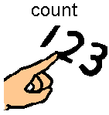
- Next I stop! Then think of things I can do. I can count to 10.
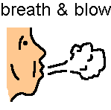
- I can breathe deeply 3 times and blow it out.
- I can use the boxes in my room
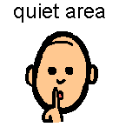
- I might want to tell the adult I need to walk away or go to a quiet area.
- I might do a relaxation exercise like the Anxiety Busters.
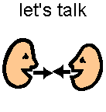
- Finally, I can try to talk with an adult about my problem and what else I can do to solve it.

Here are some pictures of me trying all these things when I feel frustrated.

Insert pictures of student trying the suggested strategies

When I try these steps I will feel so much better. I will have a lot more good days at school. I think I will try to deal with my anger and my frustration. Then I will feel better and so will everyone at school.

Insert pictures of student with teachers – both smiling

