

There are a lot of different people in this world. Some have brown hair… Some have blond hair…


People wear their hair long or short, curly or straight, and in many different styles. Usually it’s OK to compliment someone about their hair. You can say, “I like your new haircut.” Or, “your hair is so pretty today”. People compliment women about their hair. Usually people don’t compliment men about their hair in the same way. You can talk to a boy about his hair when he has a new hair style, but you would just say something like, “nice hair”.

There are a lot of different people in this world. Some are very thin… and some are heavier…

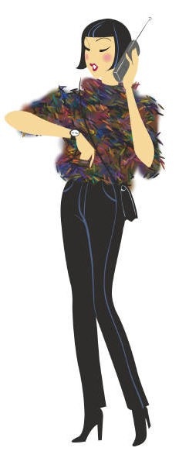

It’s usually not a good idea to talk to people about how much they weigh. If you tell someone that she is too skinny or too fat, she might feel bad.

There are a lot of different people in this world. Some people are young…. And some people are older….



Children and teenagers usually don’t mind if you ask them about their age. Adults don’t always like to talk about their age.

There are a lot of different people in this world. There are people of many different nationalities. Some people are Caucasian. This means that their skin is white or light tan. Their parents and grandparents were born in Europe or America. Here are some pictures of Caucasian people:



Some people have dark skin. They might be African Americans. Here are some pictures of African Americans:

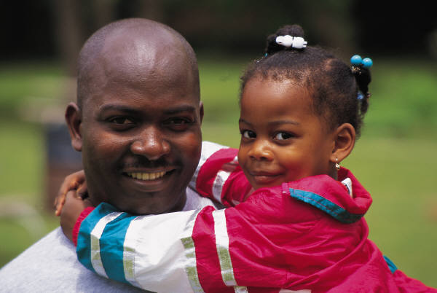

Another nationality is Asian. Asian people come from places like Korea, China, Japan and Vietnam. Asian people have light skin and almond shaped eyes. Here are some pictures of people that are Asian:

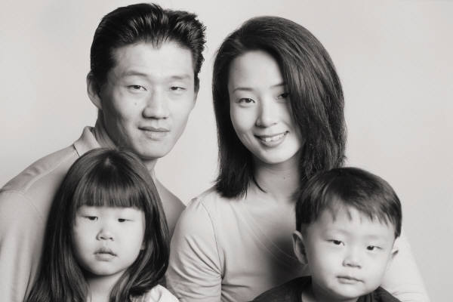

There are many other nationalities, too. When you are friends with someone, you can ask them about their nationality. You could say, “ What nationality are you?” Or, “What country are your parents or grandparents from?” You can ask friends about these things, but you shouldn’t ask strangers these questions. It is also good to remember the right words to use. “Asian” is a better word to use than Chinese. “African American” is a better term than “Black” or “Negro”.

Remember that everyone is different. Some people don’t mind if you talk about ways they are different from you, but some people don’t like it. Usually it is alright to talk to friends and family about ways they are different. It’s important to use words that are respectful and kind. Use words that won’t hurt people’s feelings. If you are not sure if the words will hurt someone’s feelings, it’s better not to use those words. You can ask your parents or your teachers about which words might hurt someone’s feelings. You can say, “Is it alright to ask someone about…….” Your parents and your teachers will usually be able to help you decide which words are kind and which words might hurt someone’s feelings.

