
Dreamcatchers
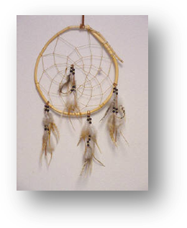
Dreamcatchers were developed by Native Americans – they are the coolest thing to have with you or hanging off a backpack or in your room or anywhere you want.

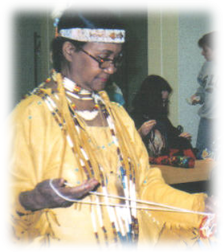
There are different ideas and uses of the Dreamacatchers. Chippewa tribes used them to ‘catch any harm that might be in the air.’ The Sioux believe that a Dreamcatcher changes a person’s dreams. Only good dreams are allowed to filter through. Bad dreams would stay in the net and disappear with the light of day. Good dreams pass through and slide down feathers to the sleeper. Other Native Americans say the bad dreams pass through the holes and out of the window and good dreams get trapped in the net and THEN slide down the feathers to the sleeping person.

Showing students how to make a dreamcatcher

Today many people buy Dreamcatchers and pretend that the things that bother them get trapped and then disappear in a day – or that the things that bother them float through and out a window. Some kids like to hang them in their rooms. Sometimes kids decorate them with favorite items and decide what bothers them and use the Dreamcatcher the way they want – then the bothersome things are just easier to deal with.

I could use a dreamcatcher for things that bother me like:

I think I would like to put my dreamcatcher

The way I want to use my Dreamcatcher is to pretend that it

