
DON’T BE BOTHERED BY LITTLE THINGS

Sometimes things bother people and sometimes things bother me. Sometimes I think I smell something.

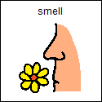

There are good smells and bad smells. If I smell something I don’t like I can do 2 things.
- I can tell myself it won’t last long and start to relax.
- I can get something that smells good and smell it.

All people smell good and bad things. If they smell something bad they just tell themselves it won’t last long and it will go away or they smell something good. My teachers and friends don’t let smells bother them. I will try not to be bothered by smells too.
Sometimes my mouth feels funny. This happens to other people too. They have a trick to help them. They take a drink of water.
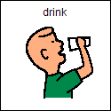
I can do this too. My teachers and friends don’t let their mouth bother them. I will try not to be bothered by a funny feeling in my mouth either.
Sometimes I feel like I have to wash my hands.
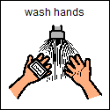
Other people sometimes feel like this too. But they can’t always do it right away and neither can I.

There are two tricks to help when you feel like you have to wash your hands.
- Ask the teacher to write down when I can wash my hands
- Ask if I can use a wipe because this is faster.
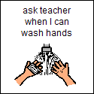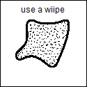
Sometimes I feel like I don’t like touching. I have to remember that touching can be a nice thing. Sometimes people touch each other when they pass each other, sometimes people touch to tell someone they did a good job like in school. Touching this way is OK. When someone touches me this way I can just tell myself this is OK.
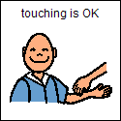

So now I know I don’t have to be bothered by little things. There are things I can do to help myself. If I smell something I don’t like I know it will go away soon and I can smell something good. If my mouth feels funny I can take a drink of water. If I feel like washing my hands I can ask someone to write down when I can or ask to use a wipe. I can tell myself that touching someone when passing each other or standing close is OK. Someone patting me to say I did good is OK too.
I will try hard not to let little things bother me and I will try to stay calm by talking softly and asking things nicely. This will make me feel good!!!

