
  - 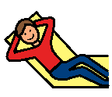 Show you are calm. Choose 1 or 2 of the following:
    - Deep breathing
    - Sit in beanbag chair
    - Walk in hall
- 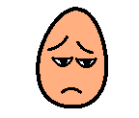Lose preferred activity.

Earn back preferred activity by completing the following:
- Do one worksheet.
- 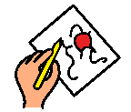Draw or 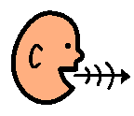talk with
an adult about what happened.
- 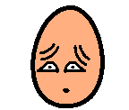Say I’m sorry to the person I
I’m sorry!
hurt.

