
CHASE GAMES

Recess is so much fun. My friends and I play games and run.
Sometimes we play chase games. We run after each other and “tag” the other person when we catch them.
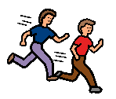
Tag means touch. When you tag someone, you touch them, then move your hand away.
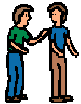
Tag does not mean to hold onto the person. When we play chase games, I will try to remember to “tag” – touch then move my hand away.

It is so much fun to chase my friends. But, sometimes my friend will say:


I’m done playing tag. Let’s play something else.

Or, my friend might say:

Please stop – I don’t want to be chased.

When my friend asks me to stop, I will try to stop right away.

We can play something else:

Let’s play ball now.

Or, I can find another friend who wants to play tag.

So, I’ll remember:

- Tag means touch – tap my friends shoulder, then move my hand away.

- When my friend asks me to STOP I will try to stop right away:

We can play another game or I can find another friend to chase.

