
Can Do!!

There are so many things I can do!
I go to school every day.
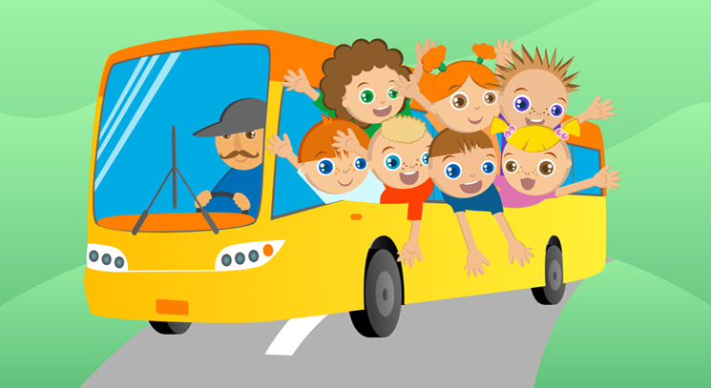
I can walk to my classroom.
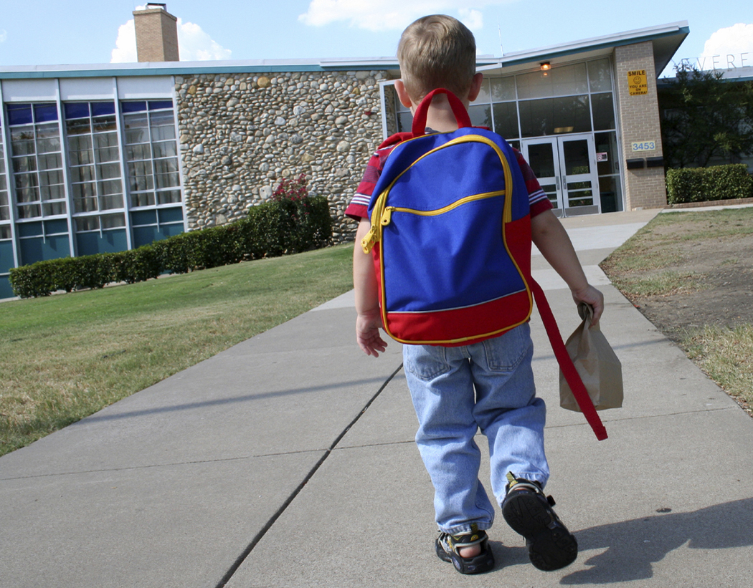
I can hang up my coat
I can sit with my friends at calendar time.

I can answer questions.
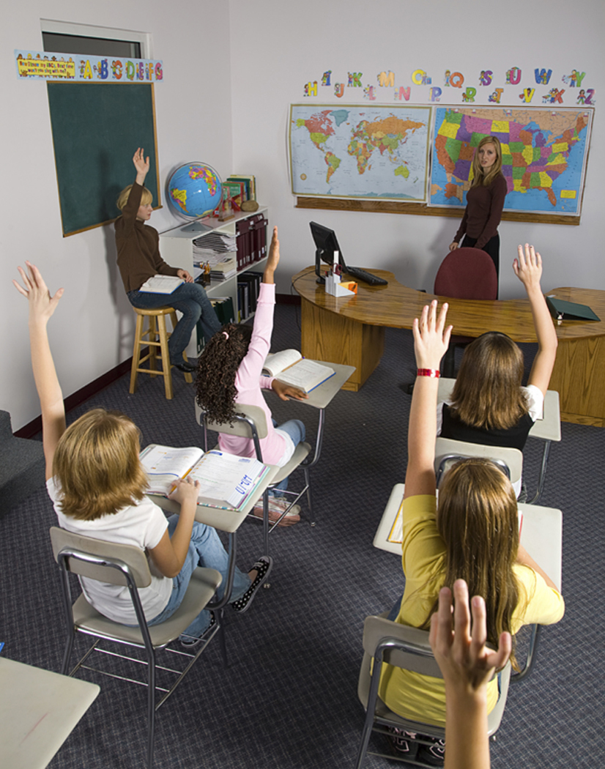
When my teacher gives a direction, I will try to follow the direction. I know I can do it. Yes I can!!!

I will try to remember to say, “Yes, I can do it.”
I will try to do my best every day.

