
Boys and Girls

There are many different kinds of friends. It is nice to have lots of friends.

Friends are people who talk together and play games. Friends are kind to each other. They say “Hi” to each other and they like to spend time together.

Boys can have friends that are boys
And, boys can have friends that are girls.
A friend that is a girl is someone to talk to and play games with. Having a friend that is a girl, does not mean that she is your “girlfriend”.

For a boy to have a “girlfriend” he should be about 15 years or older. Usually kids do NOT have boyfriends or girlfriends in elementary school. This is definitely too young for girlfriends and love. To be a “boyfriend” or “girlfriend” takes a long time too. Most kids in elementary school definitely DO NOT want to have a “boyfriend or girlfriend” or be in love! They just want friends and like to play.

Definitely Not I’m too young, I want to have fun – Let’s play Pokemon stuff!
Hey do you want a girlfriend?

Sometimes a girl may not want to be a friend either. That is OK. When that happens a kid has to stop thinking about the person and continue to be friends with other kids.

It is not appropriate to continue to talk to a person, or go after a person who does not want to be a friend. This can cause a dangerous situation for everyone and kids can get into trouble for this.

If you need to talk to someone about your thoughts on friends, it is best to talk to an adult. You can talk to your teacher, Ms. ____ or your parents, or to your counselor Ms. ___ If you need to talk to someone at school about this, you can say, “Can I talk to you privately?”

Kids in elementary school need to remember something else. They are young. They have many years to meet many different friends. They should not always think about just one person. That is not a healthy thing to do.

I have to stop thinking of this one person. It is definitely NOT HEALTHY for ME!

So remember,

- It is great to have friends that are boys and friends that are girls.
- Friends are kind to each other.
- Kids do not have “boyfriends and girlfriends” in elementary school. They just want friends NOT love.
- If someone doesn’t want to be a friend that is OK – you can have other friends.
- It is NOT ok to keep bothering someone who doesn’t want to be a friend.
- It is NOT healthy to keep thinking of one person.
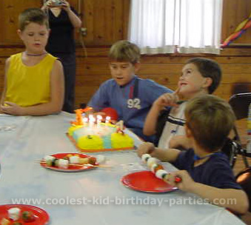
- If you are worried or have questions about another student, you can talk privately to a parent, a teacher, or a counselor.
I just want to play with friends and not think hard about one person! And I’m way too young for Love!

