
My name is xxxxxxx. I’m in high school and becoming a young man. There are

many things I like to do in school. Some of these things are: _____________, and

________________, and __________________.

There are also things that bother me. I get bothered when:

____________________________________________________________________________.

I definitely get bothered when xxx talks to me. I get bothered when xxx gets

near me.

I am doing good though. I do good when I remember not to yell – I remember

to talk softly. I do good when I remember to keep my hands to myself. I do great when I try to walk with other kids and to let an adult know I’m being bothered.

I am becoming a man –
A man does not let xxx bother him.
Right! A young man walks with other kids when bothered or tells an adult – that’s COOL!

A man does not hit.

A man does not yell.

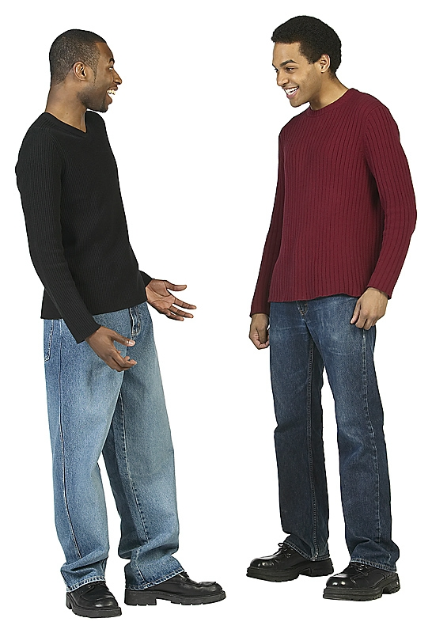
A man definitely does NOT run away.

Hey we’re in High School – we’re young men – we don’t yell, we don’t hit, we DON’T run away. Those are baby things Dude!

Mark Henry is a man for sure! Tony Atlas is a man too.

Mark and Tony only yell and wrestle when they are working in the ring. That is their job and it is entertainment it is not real.

When Mark and Tony went to school they NEVER ran away, they never hit anyone, they never yelled.

Even now, in their real life they remember to talk softly, tell someone if they are bothered, or even walk away. They keep their hands to themselves.


Mark Henry has a son and he teaches him to go to an adult if he is bothered by someone.
I teach my son to talk softly and go to an adult if he is bothered. I want him to grow into a good man!
Tony
Tony Atlas has won many awards. He said when he was in the ring it was all for entertainment. He said he really likes to paint and he is a gentle man even though he is very strong.

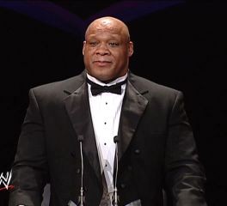
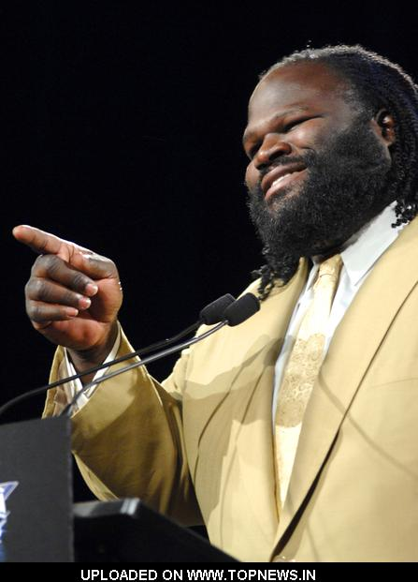
I win awards because I NEVER yell, hit, or run away when I’m bothered. I only do things in the ring and that is not real!

